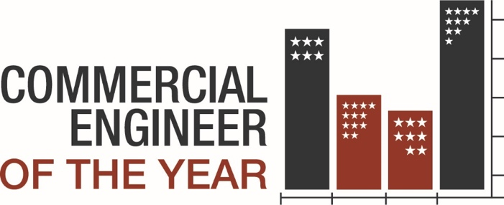

Engineer of the Year Awards Nomination Form
Apply online or submit this form to Pascha Jones, pjones@aoba-metro.org by December 15, 2024. Online judging occurs within the next few weeks and building tours/interviews occur January 2025. Nominees/winners will be announced during the Commercial Awards Celebration on February 27, 2025.

Nominator Details*
- First Name
- Last Name
- Email
- Phone

Nominee Details*
- First Name
- Last Name
- Company
- Email
- Phone

What award are you nominating this person for?*
- Chief Engineer
- Building Engineer
- Maintenance Member

Nominee Years of Experience*
- 0-3 years
- 4-6 years
- 7-9 years
- 10-12 years
- 13-15 years
- 15+ years

Nominee Education: (Only one field is required)*
- High School
- Undergraduate
- Graduate
- Technical School 1
- Technical School 2

Nominee Designation and Licenses: (Only one field is required)*
- Name
- Name
- Name
- Name
- Name

Nominee Site or Portfolio Managed*
(comment box)

Letter of Recommendation from Nominee's Supervisor*
(upload PDF, DOC, DOCX, PNG, JPG, JPEG, GIF files)

Letter of Recommendation from Nominee's Property Manager*

Letter of Recommendation from Nominee's Director of Engineering*

Letter of Recommendation from Tenant

Statement of Qualifications by Nominee*

Please describe nominee's technical knowledge*

Please describe nominee's expertise in environmental and energy conservation*

Please describe nominee's customer service experience*

Please describe nominee's ability to work with, and lead, a team*

What other information would you like the judges to know about the nominee (innovation, creativity, dealing with difficult circumstances, etc.)

