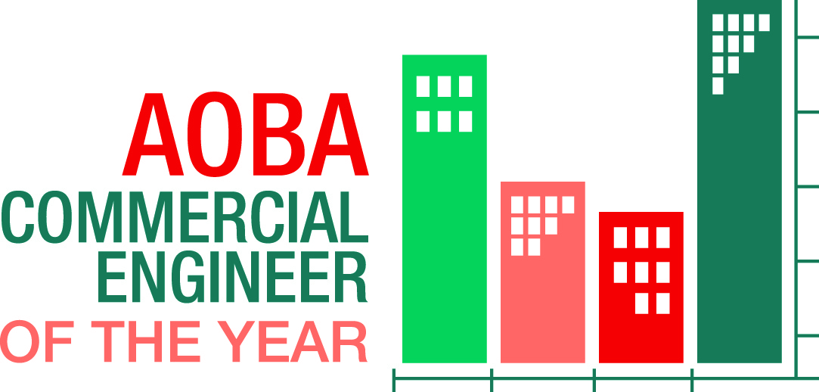

2019 MAINTENANCE TECHNICIAN OR MAINTENANCE MECHANIC NOMINATION FORM

The Commercial Engineer of the Year awards acknowledge the engineering professionals who are vital to the successful operation of our buildings. These three category awards, Chief/Lead, Building and Maintenance Technician/Mechanic will be presented at the Commercial Awards dinner on June 13, 2019 at the Fairmont Hotel, Washington DC.

Who is eligible for the Maintenance Technician or Maintenance Mechanic nomination?
Anyone who best meets the following eligibility requirements:
- 1-5 years of experience as an entry-level maintenance technician or maintenance mechanic.
- Works for a current AOBA-member firm.

How will candidates be evaluated?
Nominations will be reviewed based on the following criteria:
- Education / Certifications / License
- Technical Knowledge
- Building Operating System maintenance
- Environmental and Energy Conservation
- Customer Service
- Teamwork
- Industry and Community Involvement
- Value Add (innovation, creativity, dealing with difficult circumstances)

The judges’ building visits and onsite engineer interviews are tentatively scheduled for the week of April 15-19, 2019.

If your firm has a maintenance technician or maintenance mechanic who meets these eligibility requirements and criteria, please complete and return this nomination form, along with the required attachments by mail, or scan and email, to:
Annabel Bendz, ABendz@aoba-metro.org or AOBA, 1025 Connecticut Ave., NW, Suite 1005, Washington, D.C. 20036

Nomination deadline is Tuesday, February 26, 2019. Nomination Form Submission Cost is $150.00 per candidate. Please limit two (2) candidates per engineer category, per company. The nominee company will be invoiced after your completed submission is received.

Please be sure to carefully review the criteria for each of the (3) three categories (Chief/Lead, Building Engineer, or Maintenance Technician/Mechanic) prior to beginning a nomination package, to ensure your candidate is entered into the appropriate category.

Nominee Name:
Company:
Phone:
Email:

Years of Experience:
Site or Portfolio Managed:
Education:
Designations/Licenses:

Attachments Required – Please mail, or scan and email the following:

- Letter(s) of Recommendation from Nominee’s Supervisor(s), required, i.e., Property Manager, Director of Engineering.
- Statement by Nominee explaining his/her qualifications for deserving the award.
- Letter of Recommendation from Tenant (optional).

Additional documents are welcome. Please be sure your nomination package is complete and contains all the information requested on this page. Please note: All nominee packages will be screened for category eligibility by the committee.

Name of Person Nominating:
Contact Phone:
Email:

Questions? Please contact Annabel Bendz, ABendz@aoba-metro.org or call 202.296.3390. Thank you for your nomination.

(Maintenance Technician or Maintenance Mechanic, p. 2)

