PW1100 Fuel Nozzle Remove and Replace Instructions
STEP | INSTRUCTIONS | IMAGE REFERENCE
1 | Loosen the B-nut on fuel supply tube (FS47) attached to the No. 4 fuel nozzle and manifold (FS01) | 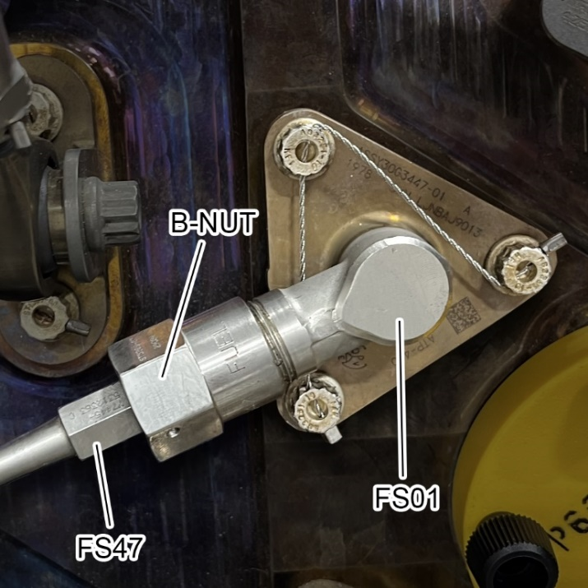
2 | Move fuel supply tube (FS47) away from the fuel nozzle. | 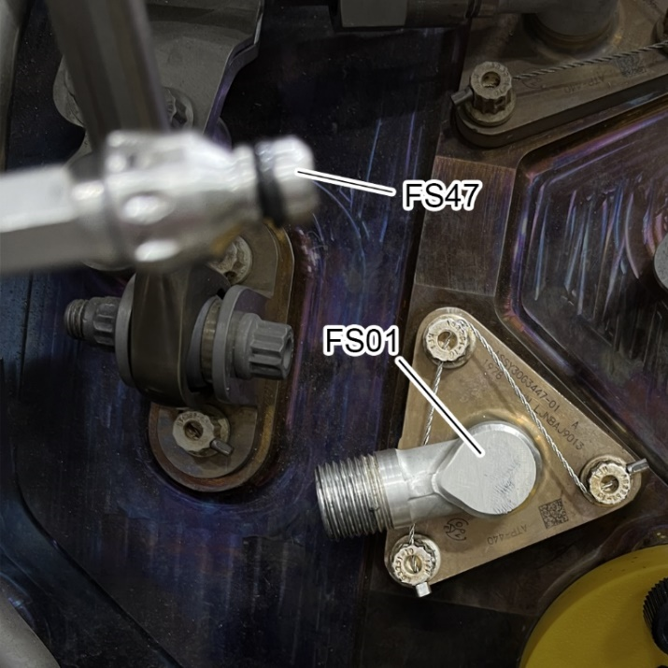

Instructions (cont.)
STEP | INSTRUCTIONS | IMAGE REFERENCE
3 | Remove safety wire from the #4 fuel nozzle bolts (3ea) and discard trash. | 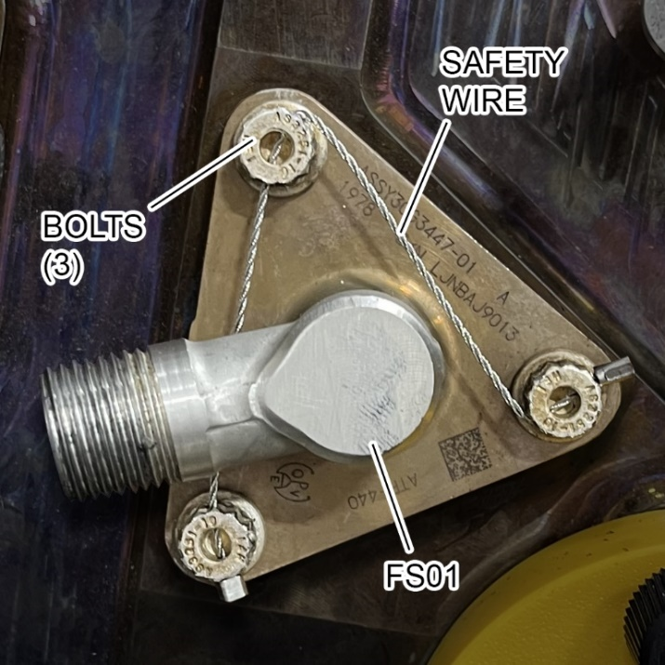
4 | Remove the bolts and store them in the parts bag given to avoid FOD.
5 | Carefully remove the #4 fuel nozzle from the diffuser case and discard the gasket. | 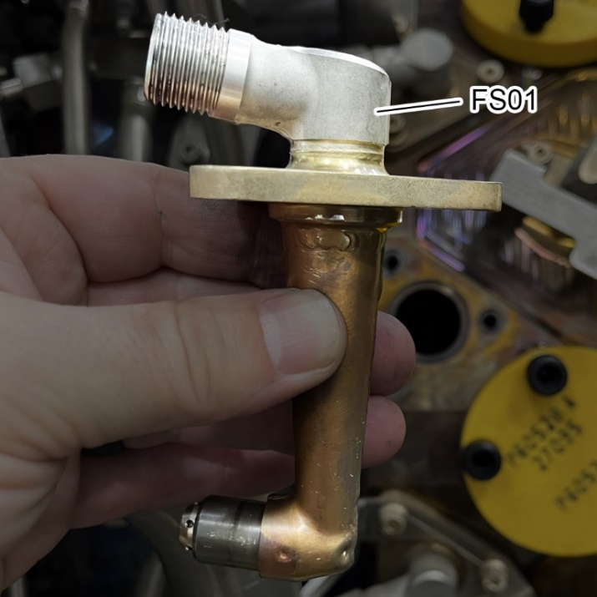

Instructions (cont.)
STEP | INSTRUCTIONS | IMAGE REFERENCE
6 | Replace the gasket with a new gasket from the table and show the inspector or judge the installation of the new gasket. | 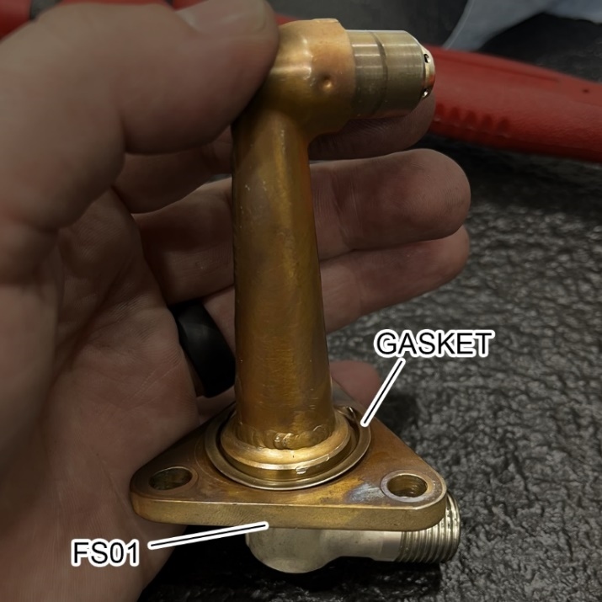
7 | Carefully install the #4 fuel nozzle into the diffuser case making sure it is in the correct orientation.
8 | Install the 3 bolts finger tight.
9 | Torque in the 3 bolts to 45 lbf-in.
10 | Safety cable the 3 fuel nozzle bolts.

Instructions (cont.)
STEP | INSTRUCTIONS | IMAGE REFERENCE
11 | Install the fuel supply tube (FS47) finger tight onto the #4 fuel nozzle and manifold (FS01).
***ENSURE TO TORQUE THE B-NUTS IN THE CORRECT SEQUENCE***
12 | Torque both B-nuts to 225 lbf-in. | 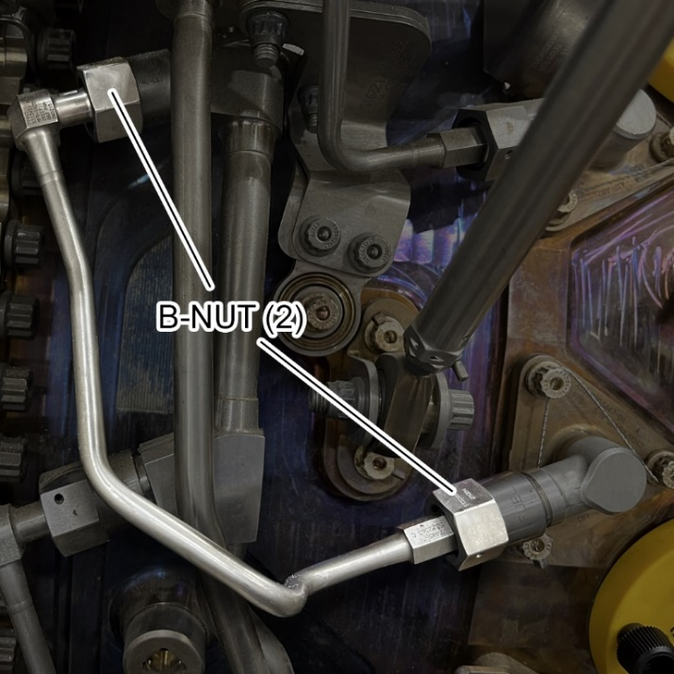
13 | Loosen both B-nuts to zero.
14 | Torque both B-nuts to 225 lbf-in
***DO NOT LOOSEN THE B-NUTS AGAIN***
Instructions (end)
STEP | INSTRUCTIONS | IMAGE REFERENCE
15 | Torque both B-nuts to 225 lbf-in
16 | Discard of all trash
17 | Set all torque wrenches to their lowest setting and store the tools.
COMPLETE

