V2500 Fuel Nozzle Remove & Replace Instructions
STEP | INSTRUCTIONS | IMAGE REFERENCE
1 | Remove all safety cable from the #16 fuel nozzle supply tube B-nut and fuel nozzle bolts. | 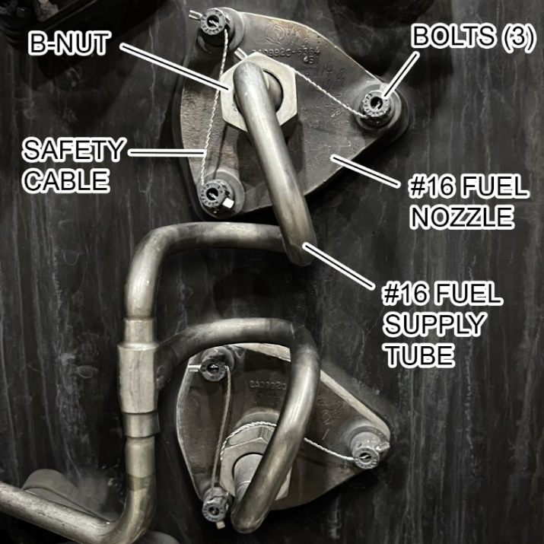
2 | Remove safety cable from the #17 fuel nozzle supply tube B-nut which is located just below the #16 fuel nozzle. | 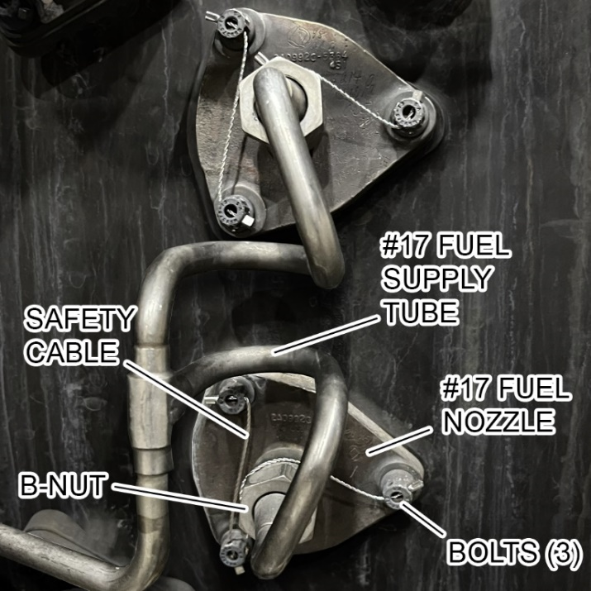
Instructions (cont.)
STEP | INSTRUCTIONS | IMAGE REFERENCE
3 | Break the torque on the #16 and #17 fuel supply tube B-nuts. | 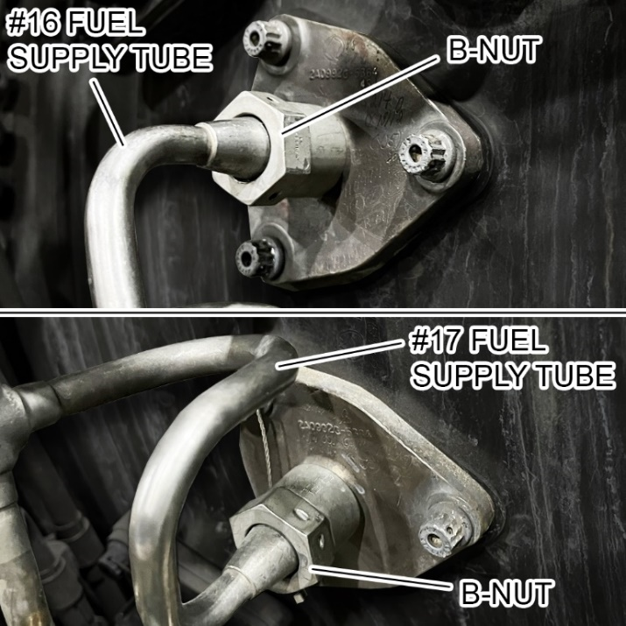
4 | Move the supply tubes away from the fuel nozzles. | 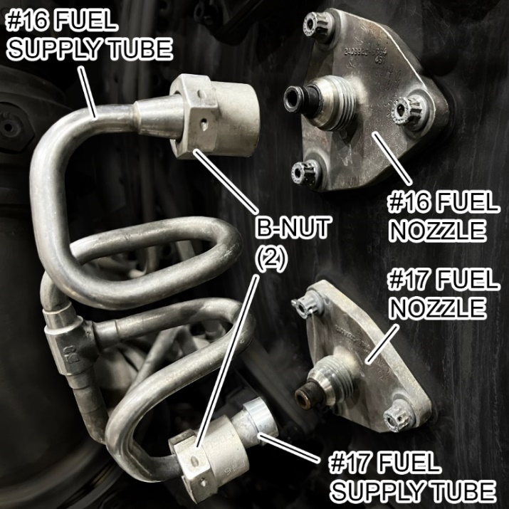
Instructions (cont.)
STEP | INSTRUCTIONS | IMAGE REFERENCE
5 | Remove the bolts from the #16 fuel nozzle and store them in the parts bag given to avoid FOD. | 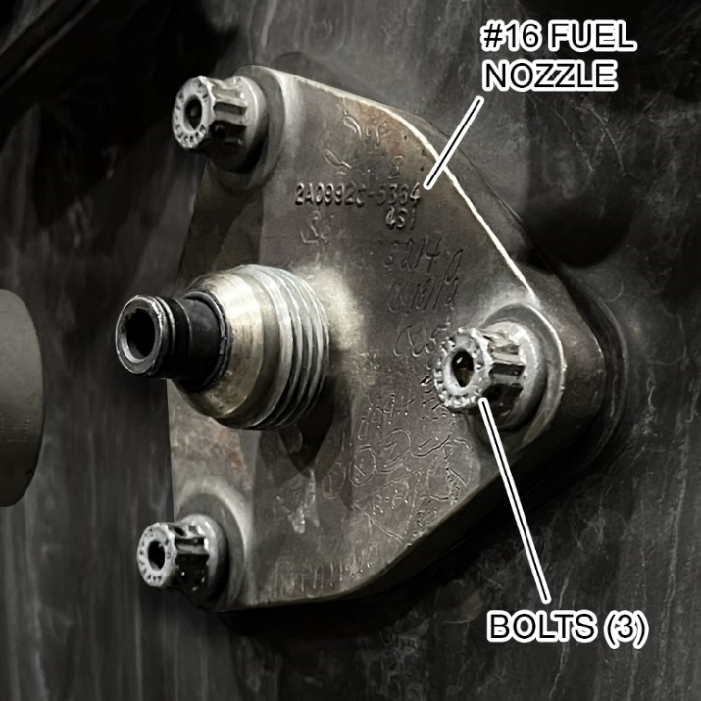
6 | Carefully remove the #16 fuel nozzle from the diffuser case and discard the gasket. | 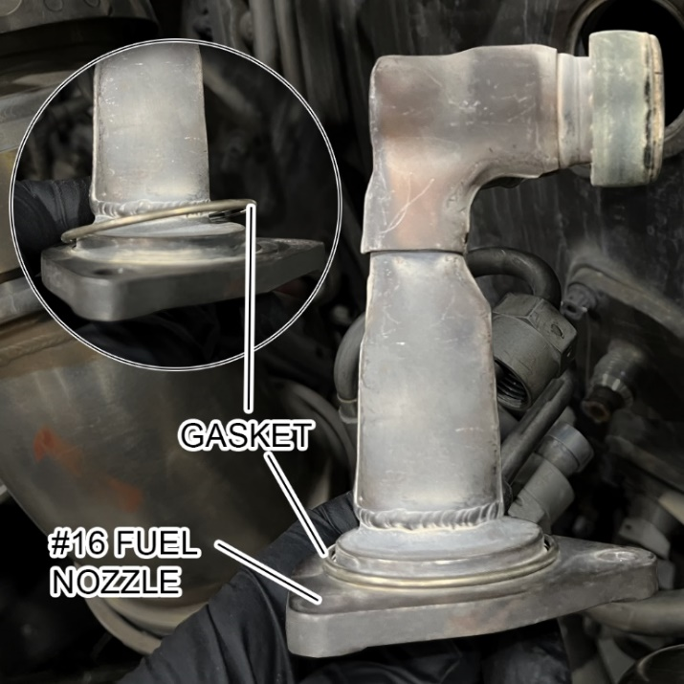
Instructions (cont.)
STEP | INSTRUCTIONS | IMAGE REFERENCE
7 | Replace the gasket with a new gasket from the table and show the inspector or judge the installation of the new gasket. | 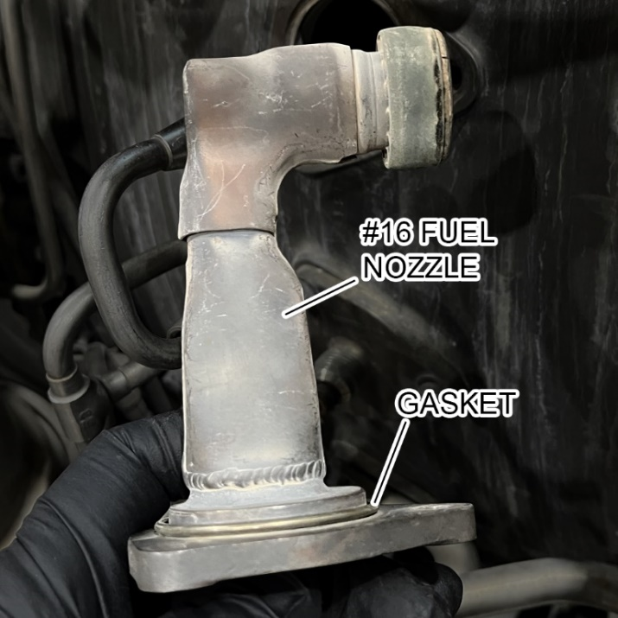
8 | Carefully install the #16 fuel nozzle into the  diffuser case making sure it is in the correct orientation. | 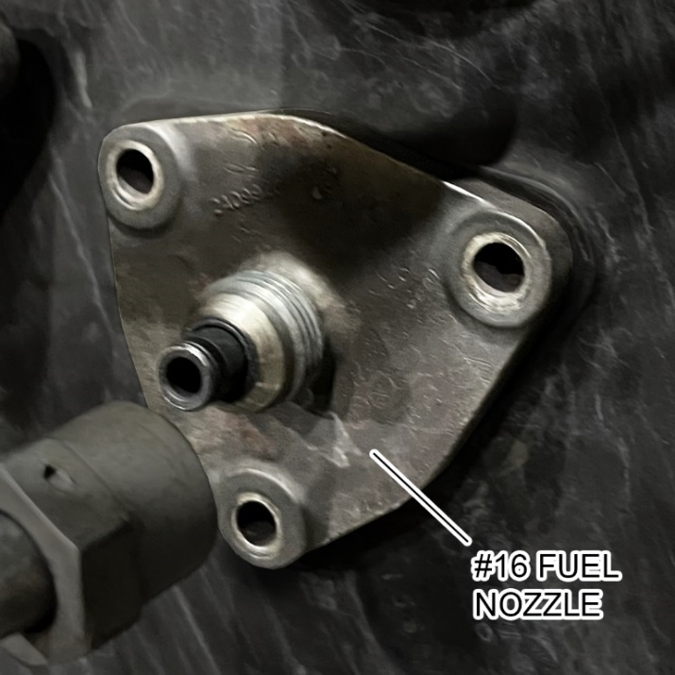
Instructions (cont.)
STEP | INSTRUCTIONS | IMAGE REFERENCE
9 | Install the 3 fuel nozzle bolts finger tight.
10 | Torque in the 3 fuel nozzle bolts to 65 lbf-in.
11 | Install the #16 and #17 fuel supply tube B-nuts finger tight.
Instructions (cont.)
STEP | INSTRUCTIONS | IMAGE REFERENCE
***ENSURE TO TORQUE THE B-NUTS IN THE CORRECT SEQUENCE***
12 | Torque the #16 and #17 fuel supply tube B-nuts to 205 lbf-in.
13 | Torque the #16 and #17 fuel supply tube B-nuts to 205 lbf-in again.

Instructions (end)
STEP | INSTRUCTIONS | IMAGE REFERENCE
14 | Safety cable all bolts and fuel supply tube B-nuts. | 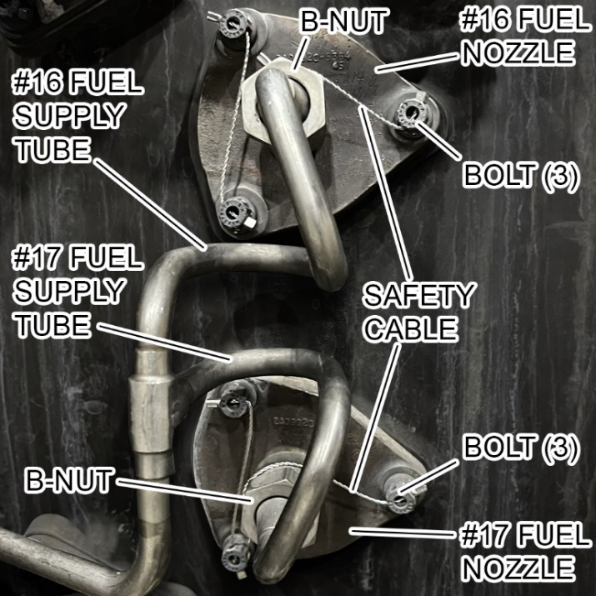
15 | Discard of all trash
16 | Set all torque wrenches to their lowest setting and store the tools
COMPLETE

