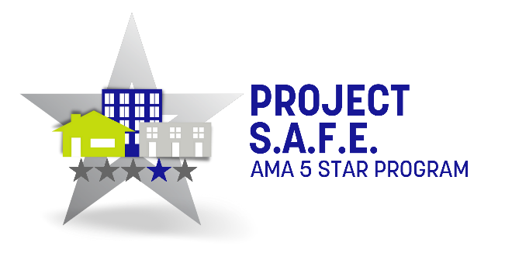

Dear [insert contact/business]

I am writing this letter on behalf of [insert community] located at [address], a proud member of the Arizona Multihousing Association (AMA), the statewide trade association benefitting the rental industry. As part of our membership with the AMA our community participates with the Project S.A.F.E. program which benefits our residents through outreach efforts inclusive of safety presentations, family fun activities and neighborhood revitalization efforts.
This year our theme is [insert theme] and we expect approximately [insert number] residents and neighbors to turn out on [insert date of event] at [insert event location]. My hope is that you will consider providing an in-kind donation of [insert product] and in return attend to meet and greet residents and/or distribute information about your business such as coupons, menus, business cards, etc.
Last year AMA members organized over 100 Project S.A.F.E. events statewide serving thousands of families and residents. It is the AMA’s most popular outreach program and a premier opportunity to bring together apartment communities, businesses, organizations and neighbors. I thank you in advance for your generosity and support of building strong and safe communities.
Kindly,



