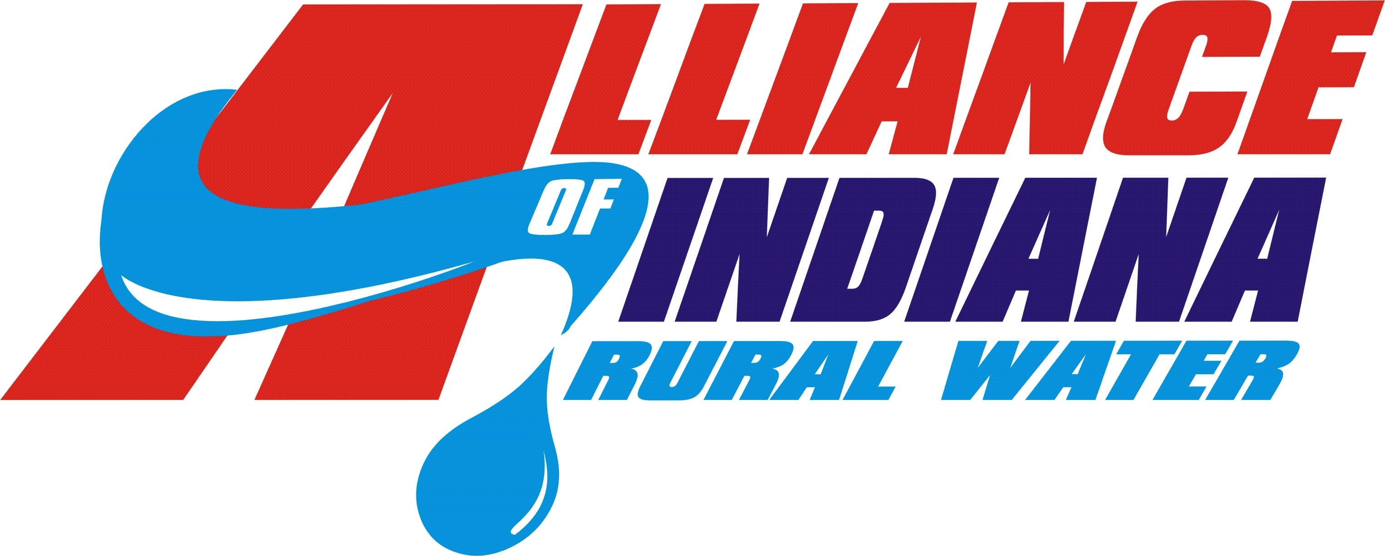
Phase II Guidance
The Wellhead Protection Plan (WHPP) Phase II update modifies the original Phase I plan to reflect changes or steps taken to implement the plan since the original approval. Phase II updates are accepted up to one year before they are due. Find your Phase II due date at http://www.in.gov/idem/files/wellhead_comm_pws_database.pdf . The Phase II submittal consists of the IDEM Phase II application form and addendums explaining the changes from each chapter or section of the WHPP. The updates required depend on what was included in each Phase I, but a typical list is below. Contact Toby Days or Sky Schelle at 888-937-4992 with questions or for an example Phase II submittal packet.

1. Using the IDEM form at http://www.in.gov/idem/4289.htm#phase2 submit the last 5 years’ pumping totals to IDEM’s geologist, Travis Cole tcole@idem.in.gov . If pumping has increased by 10% or more, a new well was drilled, or you began pumping over 100,000 GPD since Phase I, IDEM may require you to have a certified geologist re-delineate your WHPA. If a new well was drilled, contact your IDEM inspector for verification that your wells comply with state construction standards and permits. To meet this requirement, the Alliance has submitted emails from the inspector.
2. Update the Local Planning Team (LPT). A meeting is not required but recommended. Update your LPT members indicating their affiliation. At least one LPT member needs to be an affected party meaning they drink your system’s water or live or work within your WHPA.
3. Update the list of Potential Contamination Sources (PCS), PCS Map, and notify the new PCS owners and/or new PCS facilities of their inclusion in the WHPP, how they can reduce the threat to their drinking water, and where a copy of the WHPP can be found. A windshield survey may be necessary to determine changes to the list of PCS. The Alliance can assist with PCS mapping and has a form letter to assist you with PCS notification.
4. Update the Sanitary Setback information if changes to well security, operating procedures, and communications with local commerce/transportation agencies that surround your wellfields were made. Any efforts taken to seal abandoned wells with the WHPA should also be included in the Phase II.
5. Document at least one Local Responder Training that’s occurred since Phase I was approved. IDEM does not define ‘Local Responder Training’; possible training events include HazMat, Spill Response, and Homeland Security training. IDEM will accept a sign-in sheet listing the type of training, who attended, and the date training was completed. Your utility should be discussed or represented at the training event.
6. From the WHPP’s Phase I contingency plan, update the contact list of emergency responders.
7. Update any changes to the list of Critical Water Users and if necessary, update your procedures and methods for notifying Critical Water Users of an emergency.
8. Update progress made on the implementation steps / management measures the Phase I said would be done. IDEM does not require that each item be complete; they just want to know what progress, if any, has been made. You can also edit the list of activities to better reflect current resources and commitments. The Alliance has a spreadsheet to help you track progress on implementation steps / management measures. If you want to showcase your progress, fill-out an application for a Hoosier Water Guardian Award at IDEM’s web site: http://www.in.gov/idem/4296.htm .
9. Contact IDEM’s Public Water Supply Compliance staff, April Swift aswift@idem.in.gov or Stacy Jones sjones@idem.in.gov for the most recent Standardized Monitoring Framework.
10. Type a narrative cover sheet and a new table of contents to explain what pages/sections were updated and why the changes were made.
11. Fill out the Phase II application form http://www.in.gov/idem/5157.htm#owq_wellhead and submit it with your updated WHPP.

