Water Line Maintenance Technician

Patoka Lake Regional Water and Sewer District currently has an opening in the Transmission and Distribution department. This department manages the construction and maintenance of all water lines, booster stations, meters and more. Members of this department are on-call every fourth week to provide 24-hour emergency response.

**Responsibilities:**

* Learn and perform maintenance on water lines, valves, and hydrants.
* Assist in general operations including mowing, painting, meter reading, meter repair and more.
* Respond as needed to emergency situations, such as water main breaks or leaks.
* Learn to operate and maintain equipment under the guidance of experienced technicians.
* Keep accurate records of maintenance activities and assist in documenting inventory and inspections of the water distribution system.

**Requirements:**

* 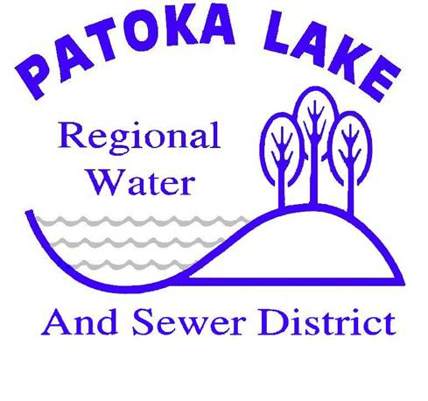Valid driver’s license
* Ability to obtain class A CDL
* Monthly on-call duties
* Random drug testing
* Ability to perform heavy tasks in outdoor conditions

**Benefits:**

* 40 hour week
* Health, dental, vision, life insurance
* Paid time off
* Public employee retirement

Apply online at **plrws.net** or submit resume to [Luke@plrws.net](mailto:Luke@plrws.net)

Patoka Lake is an equal opportunity employer. All qualified applicants will receive consideration for employment without regard to race, color, religion, sex, age, national origin, genetic information, disability or protected veteran status.