**FOR SALE**

**Used 20HP Gardner Denver Sutorbilt GAELDPA 5LP Rotary Lobe Positive Pressure Blower Pkg**

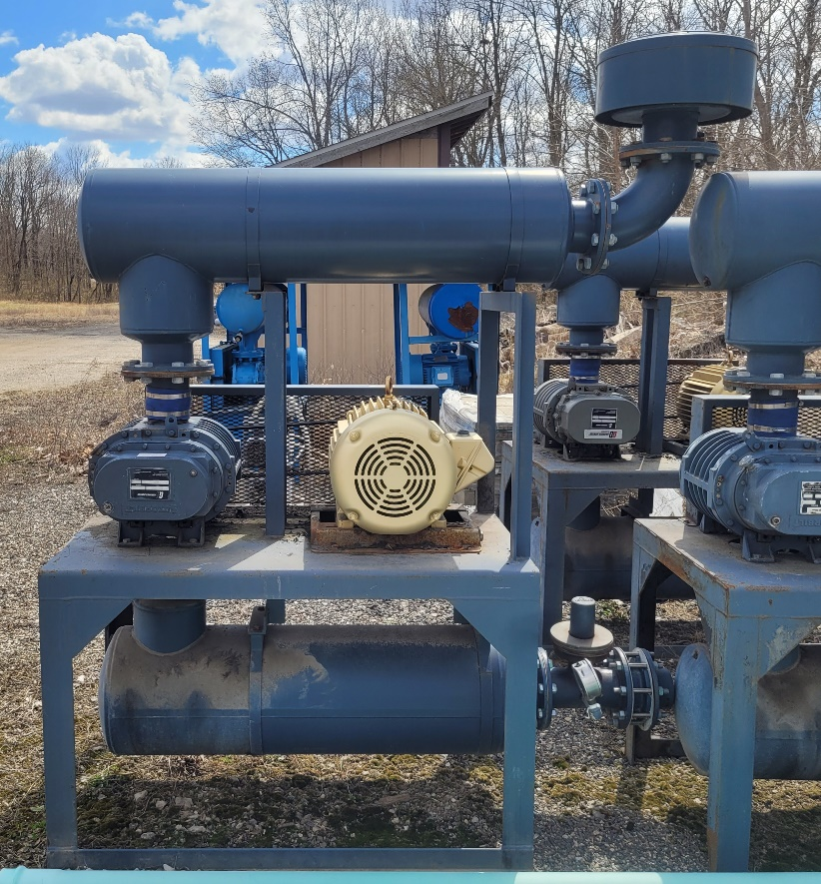 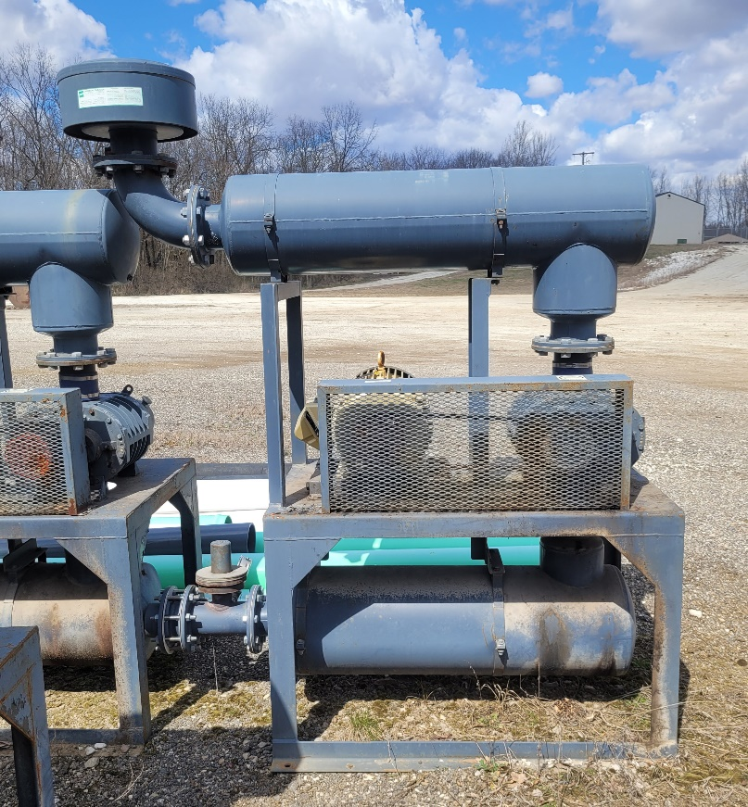

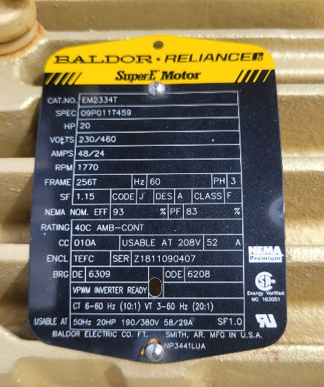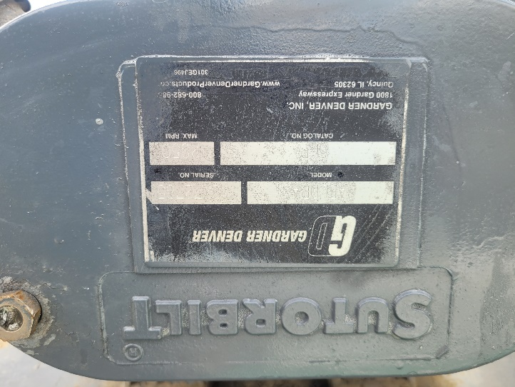

Town of Veedersburg WWTP

Veedersburg, IN 47987

765-299-5136

$5,000.00

(freight not included)