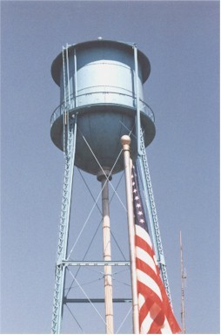
Battle Ground Conservancy District
P.O. Box 303
Battle Ground IN 47920
Email: water@battleground.in.gov

Job Description for Water Works Assistant:
This position is to assist the Operator and to learn the requirements of a Water Works Operator, with the intention of certification as a WT2 and DSL Operator. This position is for someone that wants to make this a career as there is 2 years of schooling before getting your licenses. As a requirement you have to get your license within one year after passing the course for continued employment. As we will be putting time and money into your education, training and skills, there will be a contract with the Battle Ground Conservancy for 3 years after you get your licenses. If you fail to get your licenses or quit or leave before the contract is done, you will owe the Conservancy for the money spent on classes, training material.
Hours: 7:00 AM – 3:30 PM. 30 hours per week.
Must be able to work weekends and holidays as needed including 24 hour on call.
Education:
High School diploma/GED required. Vocational/Technical school in water works/wastewater operations desired.
Experience:
Mechanical experience in one of the following areas; water, wastewater, plumbing, metering or backflow prevention preferred.
Knowledge, Skills, Abilities:
Must have the ability to succeed in training and continuing education. Good verbal communication skills. Ability to perform basic mathematics. Must be able to lift 50 to 80 lbs. frequently and up to 100 lbs. occasionally. Computer skills including a familiarity with word processing, spreadsheet and database applications preferred.
Must have and maintain a valid Indiana Driver’s License with non-high-risk insurance.
Must be able to pass a background check and E-Verify authorization.

