FOR SALE
HACH DR6000 SPECTROMETER and
HACH DRB200 HEATING/DIGESTION BLOCK
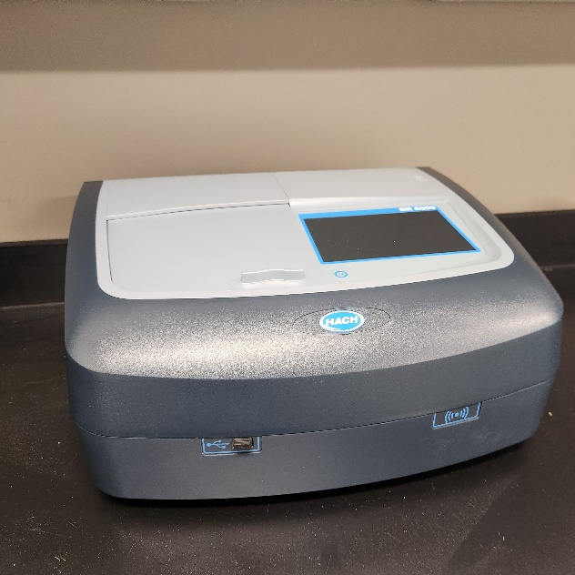
Purchased new approximately 2017 but never used.
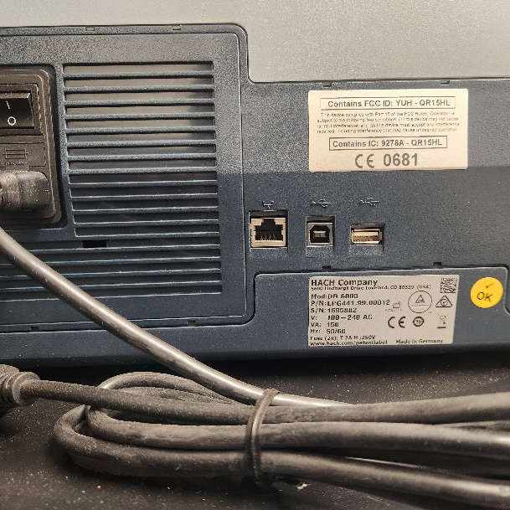

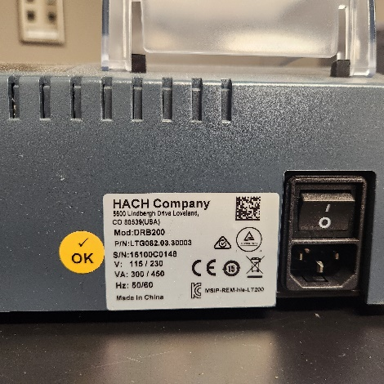
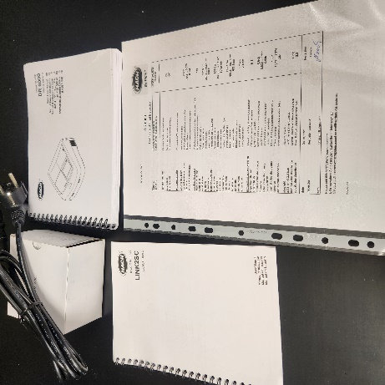
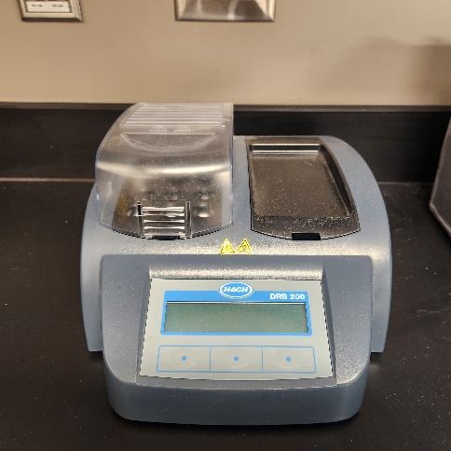

Contact:
Lichelle Parker
Lakeland Regional Sewer District
5002 E 100 N
Warsaw, IN 46582
574-529-2383, #3
LParker@LakelandRSD.com

