**FOR SALE**

**USED ASCO Transfer Switch**

Catalog # J03ATSA30400NGXH BOM 1307311

Serial # 2084579 400 A 3 Phase 480 V 50-60 HZ

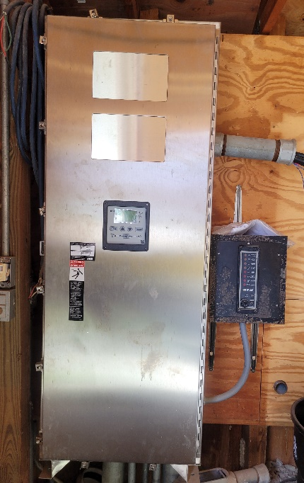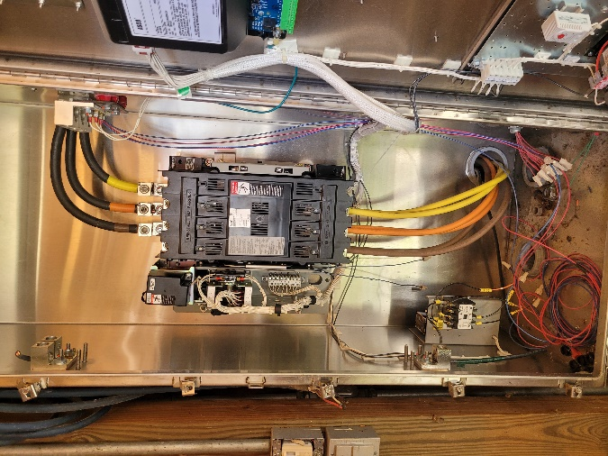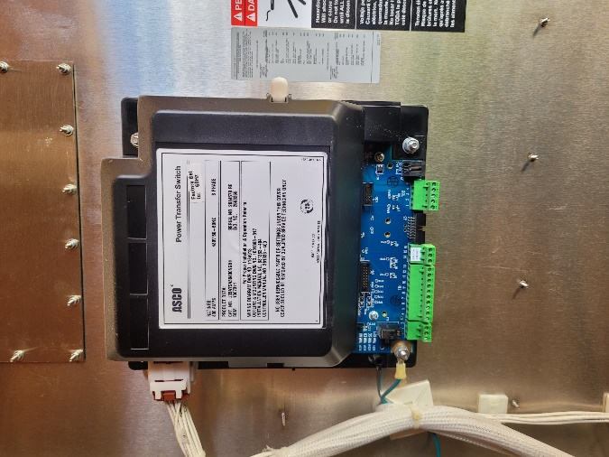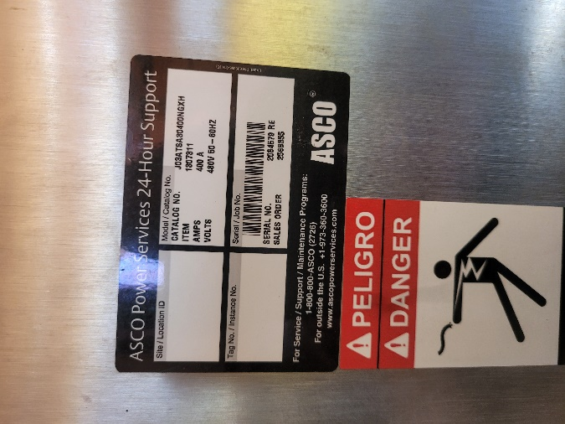

Town of Veedersburg WWTP

Veedersburg, IN 47987

765-299-5136

$1500.00

(freight not included)