**FOR SALE**

**USED GREYLINE LEVEL & FLOW MONITOR**

Model # SLT 5.0 Serial # 77826

100-240 V 50/60 HZ

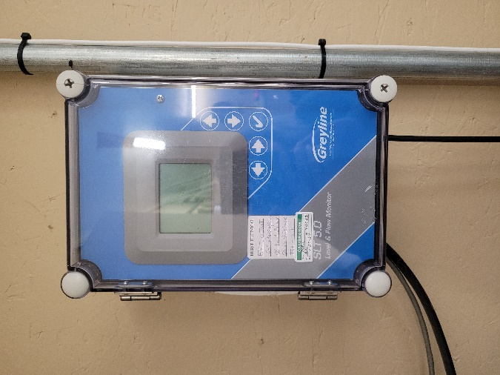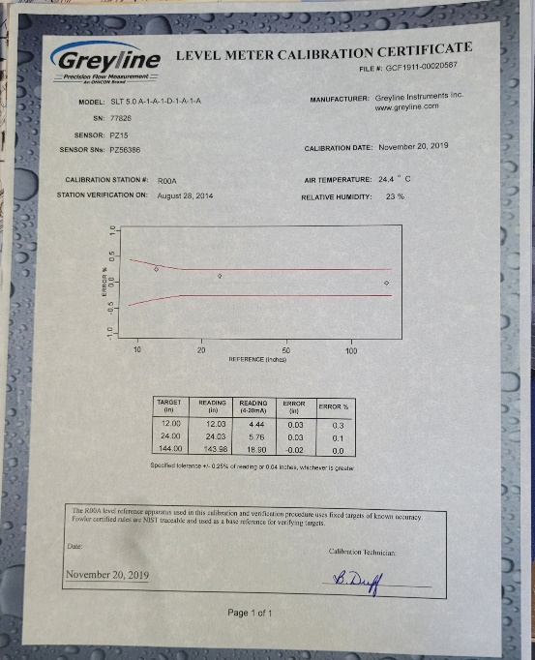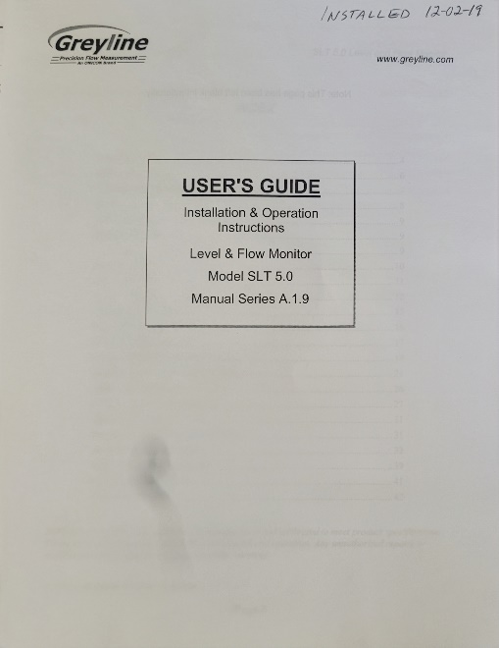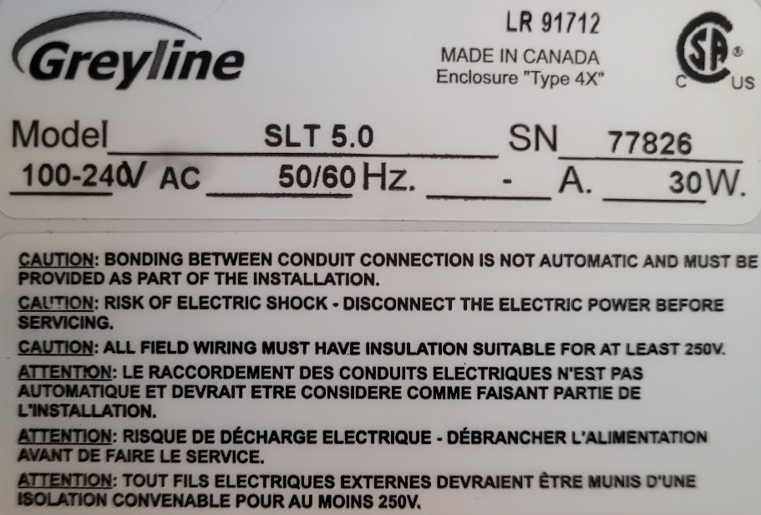

Town of Veedersburg WWTP

Veedersburg, IN 47987

765-299-5136

$1000.00

(freight not included)