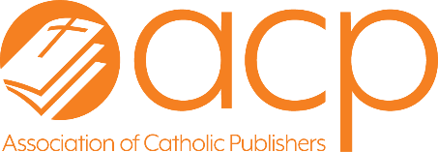
Association of Catholic Publishers

News Release
September 2, 2025
FOR IMMEDIATE RELEASE
Contact: Therese Brown, tbrown@catholicpublishers.org

A Journey through the Catechism Named ACP 2025 Resource of the Year

BALTIMORE, MD —The Association of Catholic Publishers (ACP) is proud to announce that A Journey through the Catechism, published by Ave Maria Press, has been named “Resource of the Year” in its annual “Excellence in Publishing Award” competition.
This is the second time in 3 years that a book focused on the Catechism of the Catholic Church has been the ACP “Resource of the Year.”
The judges emphasized how well the author, Fr. Daniel Mahan, director of the Institute on the Catechism at the USCCB, captured the heart of the Catechism text in this new title and made it very accessible. The question-and-answer format and the beautiful sacred art included throughout present the Catholic faith with wisdom and clarity. They agreed that this is an excellent resource for homes, classrooms, OCIA, and parish libraries.
Another Ave Maria Press book, Jesus, Make Me Fully Alive: 30 Holy Hour Reflections, was this year’s runner-up. This spiritual guide encourages Eucharistic Adoration, making it not only a doable practice, but appealing one, wrote one of the judges. Its approachable style is ideal for high-schoolers, college students, and young adults.
A Journey through the Catechism took first-place in the “Resources for Ministry” category. Jesus, Make Me Fully Alive was the first-place winner in the “Prayer: General” category.
The Resource of the Year is judged by a three-person panel. They evaluate the first-place winners of the Excellence in Publishing Awards in 19 different categories including Music ibased on 8 criteria that address audience appeal, potential impact on Catholic thinking, action, and faith/spirituality, and whether it would be a Catholic “classic” or best seller.
The Association of Catholic Publishers (ACP) is a membership organization of Catholic publishers, those who provide services to Catholic publishers, and individuals who work with Catholic publishers. The ACP provides opportunities for members to further the Catholic publishing industry, promote Catholic publishing and reading, and engage those they interact with, including retailers, pastoral leaders, individual customers, and staff.

– 30 –

To schedule interviews, contact Therese Brown at 410-988-2926 or at tbrown@catholicpublishers.org.

