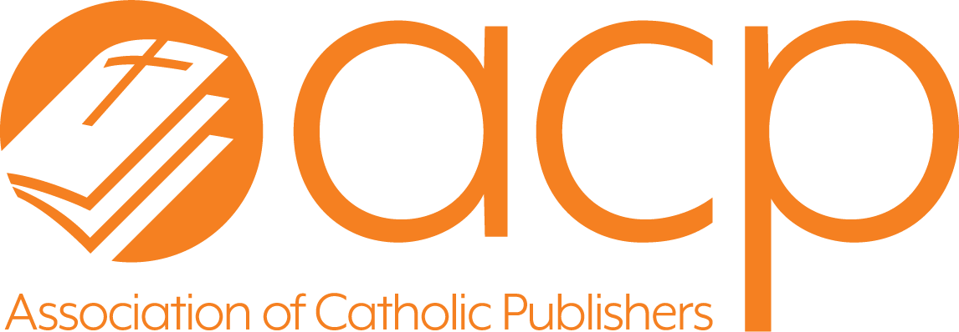
ACP Excellence in
Publishing Awards
Submission Form and Instructions

Thank you for supporting the Association of Catholic Publishers’ Excellence in Publishing Awards.

The goal of these awards is to recognize the best in Catholic publishing in nineteen (19) categories. (See the attached for a description of each category.) In addition, a “Resource of the Year” will be named from among the first-place finishers in these sixteen categories by a separate judging panel.

Here is the basic information that you will need in order to submit your 2024 titles.

Cost: Cost per title is based on the total number of titles submitted.
- For 1-4 titles: $125 per entry (ACP Members); $165 per entry (Non-ACP Members)
- For 5-9 titles: $105 per entry (ACP Members); $135 per entry (Non-ACP Members)
- For 10 or more titles: $95 per entry (ACP Members); $125 per entry (Non-ACP Members)

Deadline for Submission: Resources must be submitted to the ACP by December 21, 2024.

Eligibility Requirements
- Non-music resources must have a 2024 copyright date to be eligible for submission.
- Music resources must have a 2022-2024 copyright date to be eligible for submission.
- Composers must have published at least one composition published within the past 18-24 months.

Award Announcement: Winners will be announced in June 2024. A first, second, and third place award will be given in each of the sixteen categories; if there are only four titles submitted, only first place will be awarded.

Submission Instructions
Please complete one copy of the attached form or submit your entries online at https://www.surveymonkey.com/r/3X79HDX.

Submissions must be sent in print form. Please send three copies of each book you are submitting along with a completed submission form for each title to the following address by December 21, 2024.
Association of Catholic Publishers
Attn: Book Awards
4725 Dorsey Hall Drive, Suite A, PMB #709
Ellicott City, MD 21042
If you have any questions or concerns, please contact the ACP office by email at tbrown@catholicpublishers.org or by phone at 410-988-2926. This information will also be available online at the ACP website at www.catholicpublishers.org.
Category Descriptions

Though the categories below reference “books” as the object of the submission, submissions are largely format neutral with the exception of the music categories. Resources should be submitted based on the content of the resource, e.g., multimedia liturgical item would go under Resources for Liturgy. Compilations of previously published works are not accepted in any category.

Biography
Books in this category include biographies or autobiographies of Catholics whose work has made a valuable contribution to the Church and the world on a local level (through a ministry, e.g.) or a universal level (as a member of the Church’s hierarchy, e.g.) or whose example, teachings, or writings enrich Catholic spirituality and have had a wide-reaching influence.

Children/Youth: Picture Books
Books in this category are primarily written for young children who are learning to read. These titles may cover specific aspects or general information about the Catholic faith, the Church, or Catholicism; will be heavily illustrated.

Children/Youth: Young Readers
Books in this category are primarily written for children from reading age to age 11. These titles may cover specific aspects or general information about the Catholic faith, the Church, or Catholicism. This category does not include resources for preparation for specific sacraments. (See Resources for Liturgy.)

Children/Youth: Teens
Books in this category are primarily written for youth between ages 12-18. These titles may provide instruction on specific aspects or general information about the Catholic faith, the Church, or Catholicism. These titles may include fiction or non-fiction with Catholic subject matter specifically directed to this age group. This category does not include resources for preparation for specific sacraments. (See Resources for Liturgy.)

Fiction
Books in this category are novels or a collection of short stories that include characters and action that reflect the Catholic faith, tradition, or practice. Titles in this category are directed toward an adult audience.

General Interest
Books in this category include Church history, collections of essays by theologians or important Catholic thinkers; books related to papal encyclicals or other Church documents; books that instruct readers on specific aspects of the faith or provide general information about the Catholic faith, the Church, or other aspects of Catholicism; books that connect an element or theme from popular culture to prayer or faith; and books on a wide-ranging variety of topics, rooted in faith, such as books on death and dying from a Catholic perspective, parenting books, and so forth.

Inspirational
This category includes devotional, spiritual, and meditation books and books on saints, holy people, and stories related to people living their faith. Unlike books on similar subjects in the general interest category, books in this group are intended to provide readers with guidance and inspiration that can compel them to make positive changes in their lives that will draw them closer to their faith and to God.

Music: Liturgical Music Resource
Resources in this category are musical in nature and intended to aid in and support the liturgy of the Church. Like other musical resources, submissions must have a copyright date of the past 3 years including the current year. Examples for this category include missals, hymnals, books of songs, piano variations on hymn tunes, and seasonal musical resources that provide use texts and tunes to celebrate the Liturgy, e.g., Triduum.

Music: Song of the Year
The award for "Song of the Year" honors liturgical compositions that address specified themes. For 2024, the theme is the Eucharist. The text of the hymn or song must stand out among others for its theological depth, poetic beauty, and inspiration while the musical setting must be accessible, original, and reflect a seamless marriage with the text. Theme will vary by year.
Music: Distinguished Catholic Music Composer of the Year
The award for "Distinguished Composer of the Year" honors outstanding artistic achievement in the area of music composition for liturgy, worship, or personal prayer. This individual must be someone who has demonstrated excellence in the skill of music composition, have a body of work that reflects sound theology, and includes at least one composition published within the past 18-24 months.

Prayer: General
These books focus on formal or informal prayer, e.g., day-by-day reflection books, devotionals and reflection aides. Examples include 365 days of prayers, praying with the saints, books on lectio divina, as well as books that instruct in specific prayer practices like journaling or meditation.

Prayer: Seasonal Resources
These books are specifically focused on reflections for the major liturgical seasons of the Church year, e.g., Advent, Christmas, Ordinary Time, Lent, Easter. Examples of these seasonal resources include those that are based on the daily or Sunday Lectionary readings or include selections from inspirational authors.

Spirituality
These books are largely narrative in form and structured in chapters often along a specific theme. Examples include the works of authors like Richard Rohr, Julian of Norwich, or Thomas Merton.

Resources for Liturgy
This category includes any book that serves as a formation and preparation tools in parish or school ministry for sacrament preparation, liturgy, and worship. Examples of books and products in this category include Liturgy Training Publications’ Guide for Cantors, lector training resources, and sacramental preparation. This category does not include liturgical music resources. See “Liturgical Music Resource” category.

Resources for Ministry
This category includes any book that serves as a faith formation tool in parish ministry for catechesis (other than basal programs), adult faith formation, and for use in enrichment programs. Also included are resources for parish ministers. Examples of books and products in this category include Loyola’s The Catechist’s Toolbox, OSV’s Faith Fusion, and RCL’s Foundations in Faith RCIA program. Basal religion programs are excluded from this category.

Scripture: Scholarly Works
This category includes scholarly treatments of particular books or collections of books of the Bible in the vein of Raymond Brown’s An Introduction to the New Testament or Daniel Harrington’s Interpreting the New Testament. Bibles are excluded from this category.

Scripture: Pastoral Resources
Books in this category are non-scholarly or academic works that provide insights and/or suggestions into how to use Scripture in pastoral situations (e.g., in grieving ministry), explore how to use guided meditations using Scripture, or follow a "praying with Scripture” format.

Spanish
This category includes books from any awards category (inspiration, biography, prayer and spirituality, etc.) originally published in Spanish for the U.S. market. Examples include Scripture study texts, biographies (of Hispanic or non-Hispanic figures), books on prayer or spiritual reflection, liturgy resources, and books for parish ministry.

Theology
This category includes books on the topic of Catholic theology, whether scholarly monographs or more popular treatments of theological aspects of Catholic teaching on, for example, the sacraments, the nature of the Church, etc. Books that are more specifically catechetical in nature belong more properly in the “Resources for Ministry” category or basal curriculum category.

ACP Excellence in Publishing Awards
Submission Form
Directions
Submit one copy of the “Submission Form” for each title.

Category

- Biography
- Children’s Book: Picture Book
- Children’s Book: Young Readers
- Children’s Book: Teens
- General Interest
- Inspirational
- Music: Song of the Year
- Music: Liturgical Music Resource
- Music: Composer of the Year
- Prayer: General
- Prayer: Seasonal Resources
- Spirituality
- Resources for Liturgy
- Resources for Ministry
- Scripture: Scholarly Works
- Scripture: Pastoral Resources
- Spanish
- Theology

Title:
Author(s)/Composer(s):
Publisher:

