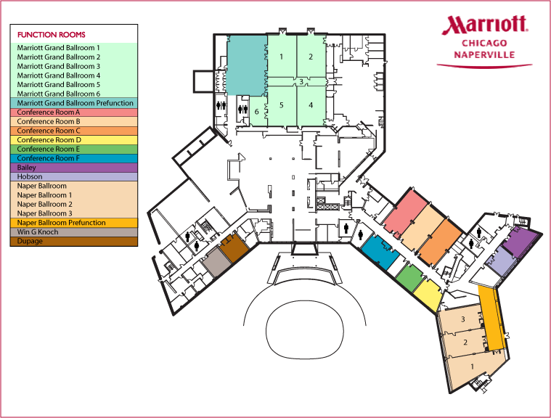
GRAND BALLROOM
Artisan Table Restaurant
West Entrance 1
Main Entrance
A
B
Great Room Bar
C
E
F
D
Pool
DUPAGE
WIN G KNOCH
Business Center
Fitness Center
Front Desk
West Entrance 2

NAPER BALLROOM

