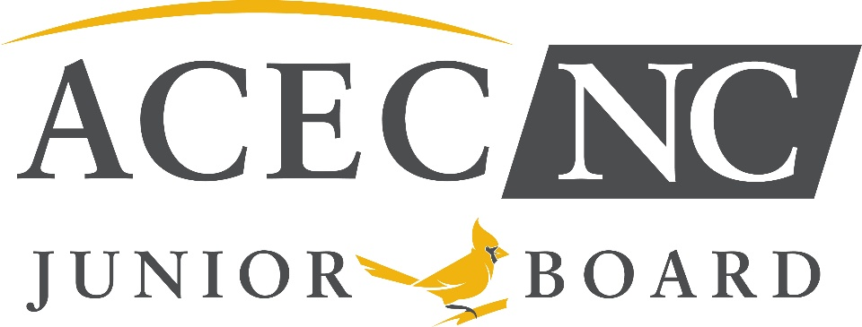

Junior Board of Directors – Nomination Form
Thank you for your interest in the ACEC/NC Junior Board of Directors (JBOD).
The ACEC/NC Board of Directors and JBOD are dedicated to fulfilling our organization’s mission and supporting our member firms. Our initiatives are guided by the ACEC/NC Strategic Plan, which was adopted in Q1 2025. This nomination is for a two-year term beginning July 1, 2026. Once Directors and Officers have been elected, a kick-off planning session with the ACEC Board of Directors will take place. This is tentatively scheduled for May. The official installation of the JBOD will take place during our ACEC Summer Conference in Asheville, July 30 – August 1.
1. Nominee Information

Full Name Job Title
Engineering Firm NC Office Location
Primary Discipline(s)
Years of Professional Experience Licensure Status (EI / PE / Other)
Email Phone

2. Strategic Alignment Statement
In a few sentences, describe why you are interested in serving on the Junior Board and how you see your involvement supporting the association’s Strategic Plan priorities.

3. Strategic Focus Area Interest
Please indicate your level of interest in contributing to each Strategic Plan focus area:

Strategic Focus Area High Interest | Moderate Interest | Limited Interest
ADVOCACY – Elevating the voice of engineering firms with legislators, agencies, and stakeholders
☐ ☐ ☐
EFFECTIVENESS – Strengthening governance, accountability, and long-term sustainability
☐ ☐ ☐
IMPACT - Supporting workforce development, leadership growth, and the future of the profession
☐ ☐ ☐
ENGAGEMENT – Expanding member participation, communication, and statewide connection
☐ ☐ ☐

4. Demonstrate Strategic Focus Area Experience & Interest
Please respond to at least two of the following:

Advocacy
What exposure, understanding, or interest do you have in engineering advocacy issues in North Carolina (e.g., procurement, QBS, infrastructure funding, licensure, regulatory issues)?
How would you help increase awareness of advocacy efforts among younger engineers?

Effectiveness
Describe any experience you have with **committee work, governance, budgeting, or organizational planning**.
How do you think a Junior Board can help strengthen the long-term effectiveness of the association?

Impact
How have you contributed to **mentorship, workforce development, or leadership growth** within your firm or the profession?
What role should the Junior Board play in preparing future leaders for the engineering industry in NC?

Engagement
How would you help engage early-career engineers across different regions, firm sizes, and disciplines?
Share one idea to improve communication, participation, or connection among members statewide.

5. Leadership & Collaboration
Describe a leadership role or project where you worked across teams, disciplines, or offices.

What skills or perspectives do you bring that would help advance one or more Strategic Plan priorities?

6. Beneficial Organizational skills:
Please circle any skills that you possess that would be beneficial to participate in the JBOD:
Fundraising Policy Development Finance Committee Budget Development Grant Writing
Media/Interviewing Podcasting Event Planning Teaching/Presenting

7. Commitment & Expectations
Junior Board members are expected to:

Attend meetings (virtual and in-person)
Participate in initiatives tied to Strategic Plan goals
Support events, outreach, and leadership development
Serve as ambassadors for the association

Do you understand and agree to these expectations?
☐ Yes ☐ No

Do you have employer support to serve for the full term?
☐ Yes ☐ No ☐ In progress

8. Perspective & Representation
What perspective, background, or experience would you bring that helps the Junior Board reflect the diversity of North Carolina’s engineering industry (geography, firm size, discipline, role, or experience)?

9. Reference (Optional)
Name Firm Relationship
Contact Information
Reference Endorsement Statement
In 2–3 sentences, why should this nominee be selected—particularly in relation to advancing the association’s Strategic Plan?

When complete, please email this form to Tammy Bromley at tbromley@acecnc.org Forms are due by 3/31/2026. Top applicants will be interviewed by a committee comprised of select members of the ACEC/NC Board of Directors and the JBOD.

