ACAF EXPO & CONFERENCE
PROGRAM & SPEAKER LISTING
December 15–16, 2026
Tuesday, December 15, 2026
1:00–1:10 PM | Welcome  Mitchell Gant  

1:10–1:20 PM | Perpetual Pavement Awards  Amy Miller / Mary Jane Hayden  

1:20–1:30 PM | Hike for Hope  Alan Mednick | American Foundation for Suicide Prevention  

1:30–2:00 PM | The Year in Asphalt  Jim Musselman | FDOT  

2:00–2:30 PM | Research Update  Mohab El-Hakim | FDOT  

2:30–2:45 PM | FDOT Workforce Development Effort  Ashley Johnston | Statewide Workforce Development  [HEADSHOT PLACEHOLDER — insert speaker photo]

2:45–3:45 PM | FDOT Roundtable  Jose Hernando, Howie Moseley, Jim Musselman, Tim Lattner, Rich Hewitt, Jennifer Marshall    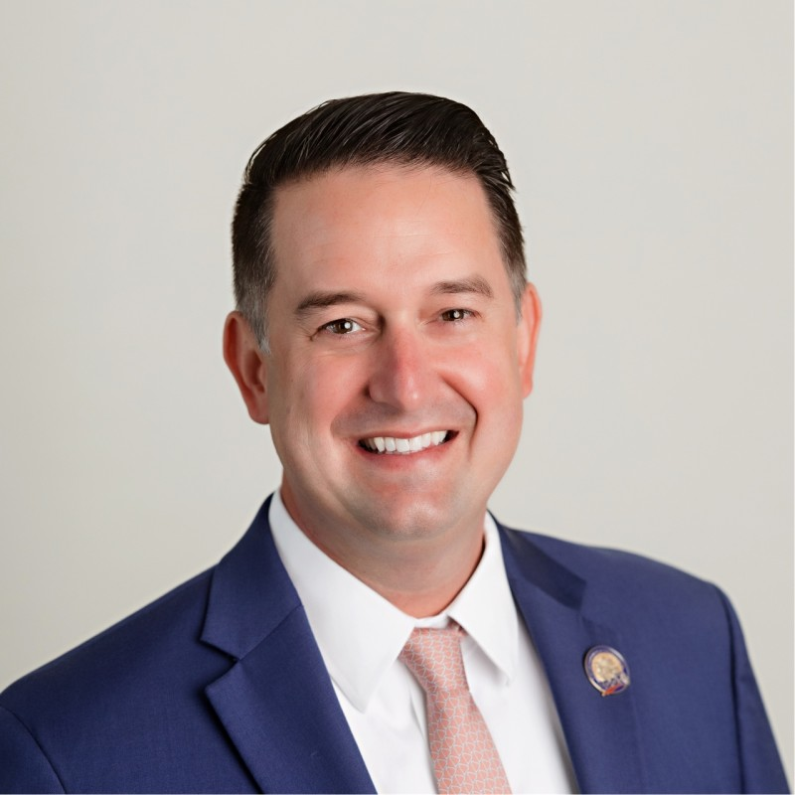

Wednesday, December 16, 2026
8:00–8:10 AM | Welcome

8:10–8:30 AM | ASCENT Leadership Academy Graduation
ASCENT Leadership Academy Graduates
  Craig Solomon |   Daniel Andrade | 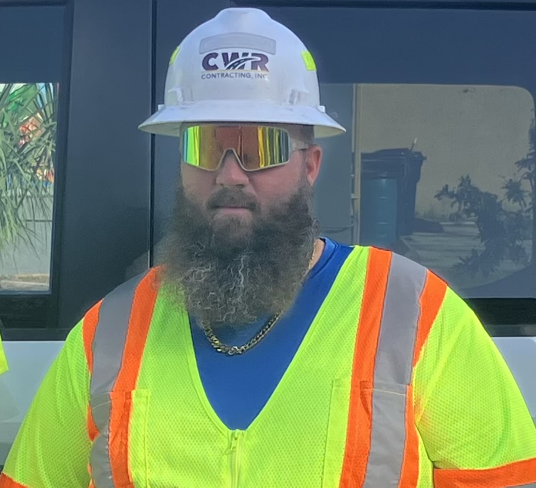  Anthony Faulkner
  Erik Jensen |   Jarrett Powell |   Kevin Collinsworth
  Max Linn | 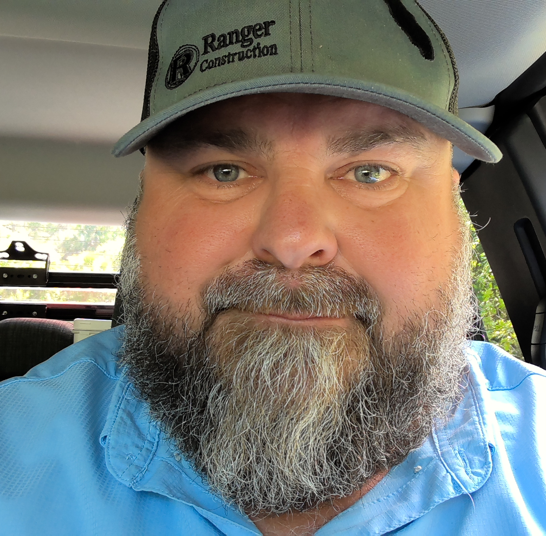  Michael Moss |   Tanner Plensdorf

Tyler Jones

8:30–9:00 AM | Asphalt Plant Maintenance Best Practices  Anthony Marcucci | Regional Production Manager, Preferred Materials, Inc.  This presentation will focus on key maintenance items asphalt plant personnel should routinely monitor to keep the plant operating safely, efficiently, and reliably. Topics include daily and weekly inspections, common wear areas, equipment condition, preventative maintenance, plant cleanliness, and identifying small problems before they lead to costly downtime or repairs.  

9:00–9:30 AM | QC Managing Best Practices  John Savage | QC Director, Ajax Paving Industries of Florida  This presentation will review Ajax’s quality-control practices and changes made following past issues with binder grade and polymer content. It will cover updates to practices, equipment, and laboratory/plant procedures, and how these changes have helped improve mix consistency, quality, and production.  [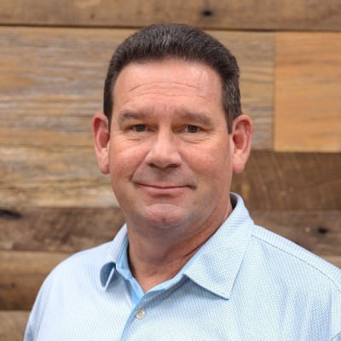

9:30–10:00 AM | Achieving Smoothness on the Roadway  Rick Crocker | Operations Manager / Area Manager, Volunteer Paving (TN)  Achieving smooth asphalt pavement starts before the paver is in gear. This session follows the paving process from surface preparation and milling through trucking logistics, screed setup and care, paving practices, and automation. It will also discuss when handwork is necessary, what quality handwork looks like, and why it may be mistaken for segregation.

10:00–10:30 AM | Break in Expo

10:30–11:00 AM | Small Steps, Big Impacts: Improving Reliability Across the FDOT Quality Assurance Process  Buzz Powell | Technical Director, Asphalt Pavement Alliance  Shortcuts in sampling and testing can introduce cumulative errors that affect QC results, QC-to-QA comparisons, QA results, and dispute-resolution testing within Florida DOT’s Quality Assurance Program. This session examines how sampling, preparation, and testing errors involving virgin and recycled materials and asphalt mixes can carry through production and acceptance. Attendees will learn how understanding these cumulative effects can help improve testing reliability, optimize pay, and minimize costly disputes.  

11:00–11:30 AM | An ACAF Member’s Success in Workforce Development  Steve Johnson | VP of Sales, Crush-It  This presentation will highlight how Crush-It developed a workforce-development program and company culture to attract, train, and retain skilled employees in a competitive labor market. Topics include recruitment, onboarding, employee development, long-term retention, clear expectations, and building a strong company culture to strengthen teams and reduce turnover.  

11:30 AM–12:00 PM | Building Safety Into Paving Equipment  Presenter to be confirmed | Wirtgen  This presentation will explore safety technologies in the paving industry, including advancements across equipment types, emerging autonomous systems, advanced braking technologies, operator control, and the connection between high-quality pavement construction and road safety. Final wording to be confirmed with Wirtgen.

