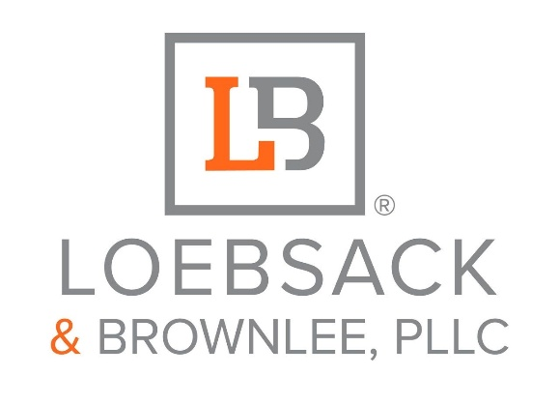

Build More Empathy. Training for leaders.

What is empathy?
According to Nursing Scholar, Professor Theresa Wiseman there are four key attributes: 1. Perspective-taking: Walk in their shoes. 2. Stay away from judgment: Active listening. 3. Recognize the emotion: Identify what they are feeling then recognize it in yourself. 4. Communication: Voice your understanding of their emotions and validate them.

There are three types of empathy:
1. Cognitive Empathy 2. Emotional Empathy 3. Compassionate Empathy

How do you practice empathy in the workplace?
1. After doing a survey and your consultant comes back with your results, see which of the three types of empathy; if not all types your organization needs. Remember, you must understand your organization's culture and values first.
2. Practice “A day in the life.”
3. Have safe roundtable conversations. Work with HR and your ERG to ensure all representation is present and no repercussions occur.

Watch this short video about empathy.

Created by: Elizabeth (Liz) Newkirk, 2022



Elizabeth (Liz) Newkirk (she/her) is the Director of Brand Management at Loebsack & Brownlee, PLLC, located in Charlotte, NC. Originally from Atlanta, GA, Liz has a background in digital marketing and analytics and is the co-author and co-founder of DEI strategies, awards, and scholarships throughout North Carolina.

Liz attended Johnson C. Smith University in Charlotte, NC, where she majored in Business with a specialization in Marketing. She holds several certifications, including Organizational Culture and Diversity and Legal Environment, from Arizona State University and has an Equal Employment Opportunity Certification from the Equal Employment Opportunity Commission (EEOC). As Manager of Digital Media with Loebsack & Brownlee, she’s managed multiple projects such as the Lecture in Law & Humanities Series at Clemson University that brings attention and awareness to social injustice and disparities to marginalized communities, and the LB Against DV Campaign which has raised over $10,000 to break the silence and stop violence across the Carolinas’ and Georgia.

A well-regarded global speaker, Liz has held leadership roles, such as being the first Woman of Color to ever serve as GCAA (Greater Charlotte Apartment Association) President of the Suppliers Council and the First Woman of Color to serve as Chair of the State Suppliers Council. In 2024, she served as Secretary of the GCAA Board of Directors, and currently serves on the 2026, GCAA Board of Directors and Education Foundation
Board of Directors Chair for the GCAA. Apart from her involvement in the GCAA, and state, Liz serves as the Inaugural Chair of the SCAA (South Carolina Apartment Association) Marketing and PR Committee, and National Apartment Association Marketing & PR Committee Chair for 2026.

Liz has won the Social Media of the Year award eight times. She has been named the 2021 GCAA Volunteer of the Year, the 2021 Supplier Partner of the Year (USAA), the 2022 Triangle Apartment Association DEI Champion of the Year, and the
2023, 2025 National Apartment Association (NAA) Excellence Award Finalist. In 2024, Liz was inducted into the class of 2024, “Top 50 Women to Know in North Carolina” by KNOW Women Media and in 2025, Women Who Inspire by Dress for Success, Charlotte. Liz is a passionate creative who loves Beyoncé, dance, her dog and coffee with cinnamon roll creamer.

