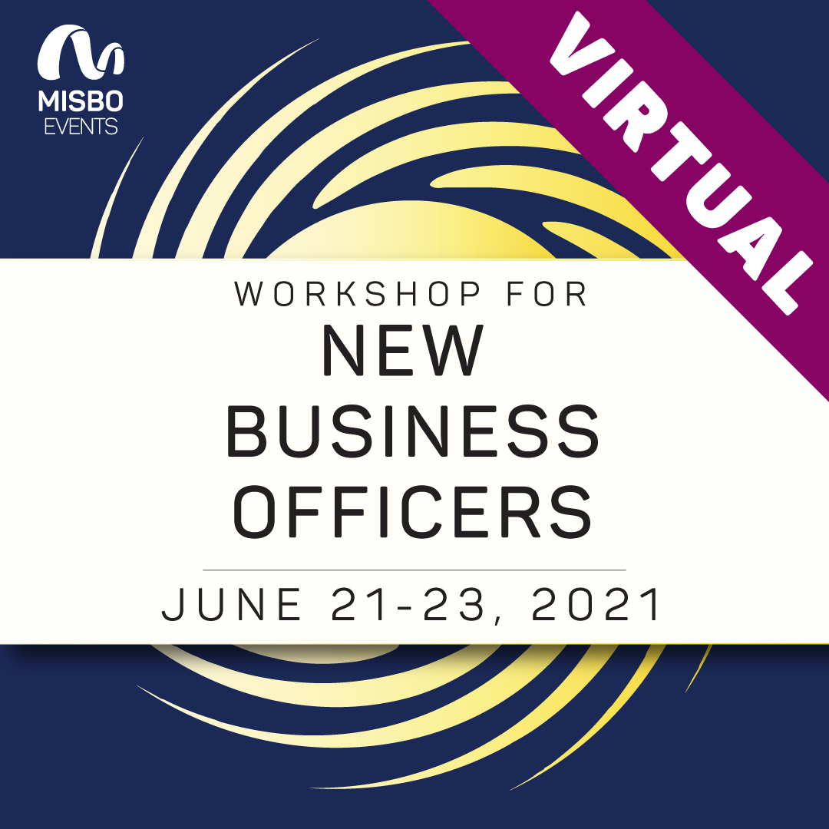

Your support of **MISBO** is so very important to the success of this event as well as to all **MISBO** events. We are excited to provide you with this “toolkit” which has everything you need to assist in helping to spread the word for a successful even in June.

*The best way to use this toolkit is to save it to your desktop along with the event logo. Then you will have everything you need to help spread the word!*

**Primary Website:** [www.misbo.com/wnbo21](http://www.misbo.com/wnbo21)

**Contact information:**

**Program Content** – Dianne Sagaas, diannesagaas@misbo.com

**Registration** – Cheryl Goode, [cherylgoode@misbo.com](mailto:cherylgoode@misbo.com)

**Event Logistics** – Lindsay Cuppia, [lindsaycuppia@misbo.com](mailto:lindsaycuppia@misbo.com)

**Sponsors** – Dianne Sagaas, diannesagaas@misbo.com

**CONFERENCE LOGO:**

(right-click on the image and choose “Save Image As”/”Save As Picture” to save locally to your computer)



**SOCIAL MEDIA RESOURCES**

**MISBO Twitter Handle:** @MISBOConnects

**Facebook**: MISBO

**Instagram:** MISBOConnects

**Social Media Hashtag:** #MISBOWNBO21

**SUGGESTED POSTS** (less than 280 characters to be tweetable; use the event logo with all posts; @tags for twitter only):

* Are you a new business officer or new to #indyschools? MISBO’s virtual #MISBOWNBO21 is a must attend! Register now at www.misbo.com/wnbo21
* #MISBOWNBO21 will provide you with opportunities to learn the skills you need to perform your work as a new #indyschool business officer. Learn more and register today! www.misbo.com/wnbo21
* Auditing and Accounting… two basics covered during MISBO’s #MISBOWNBO21. Join this virtual conference and meet others like you… just starting out in #indyschool business offices. www.misbo.com/wnbo21
* Endowment, Development, & Advancement… oh my! All this and more during MISBO’S virtual #MISBOWNBO21. Get a leg up on your new #indyschool role. www.misbo.com/wnbo21
* Hit the ground running in your new role as an #indyschool business officer. MISBO’S virtual #MISBOWNBO21 provide you with the critical tools you need to be successful in your new role. www.misbo.com/wnbo21
* Knowledge of Employment Law is critical for #indyschool business officers. We’ll tackle this and many more topics during MISBO’s virtual #MISBOWNBO21 www.misbo.com/wnbo21
* Learn the basics of Risk Management in #indyschools during MISBO’S #MISBOWNBO21. Register today and join me virtually in June! www.misbo.com/wnbo21
* HR & Payroll may look a little different in an #indyschool environment. Get a leg up on your new role during MISBO’S virtual #MISBOWNBO21 www.misbo.com/wnbo21

**LONGER LINKED-IN SUGGESTED POSTS:**

* Are you a new Business Officer or new to independent schools?

Everyone who assumes a new role needs to find their “tribe.” Those new to the business officer position need one more than ever, as they touch each and every area of an independent school. This virtual event will provide you with opportunities to learn the skills you need to perform your work, regardless of your location. Learn more and register today! www.misbo.com/wnbo21 #MISBOWNBO21

* The MISBO Workshop for New Business Officers is designed to provide you with the critical tools you need to be successful in your new #indyschool role. During this intimate learning opportunity, you will meet our exceptional faculty of independent school professionals and begin to build career-long relationships with both the faculty and your peers. www.misbo.com/wnbo21 #MISBOWNBO21
* WHO SHOULD ATTEND #MISBOWNBO21?

Business Officers relatively new to their role, Business Officers new to #indyschools, and other business office professionals who are new to their role or to independent schools, including Controllers and aspiring Business Officers. Join us virtually in June! www.misbo.com/wnbo21