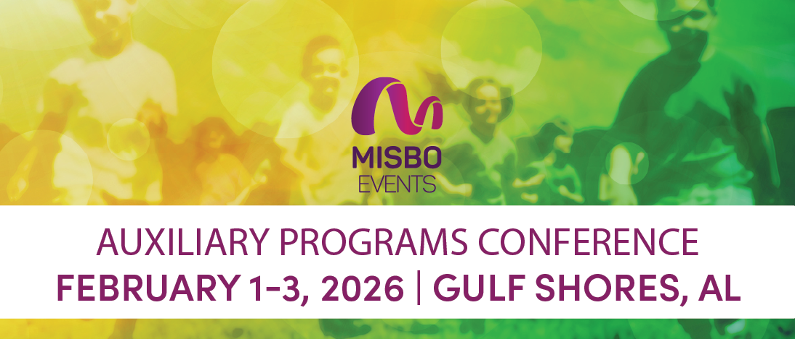

Your support of MISBO is so very important to the success of this event as well as to all MISBO events. We are excited to provide you with this “digital toolkit” which has everything you need to assist in helping to spread the word for a successful conference.

THIS TOOLKIT CONTAINS:
• Event web page
• Best contact information
• Suggested social media copy
• Social media graphic

The best way to use this toolkit is to save it to your desktop along with the event logo. Then you will have everything you need to help spread the word!

Primary Website: misbo.com/aux26

This page features all event details as well as the full event schedule with speakers and bios. Also listed are our generous sponsors who support MISBO in numerous ways and deserve attention and awareness. Their participation directly affects registration fees, so we all need to thank them for their support.

Contact information:

Program Content – Dianne Sagaas, diannesagaas@misbo.com
Registration – Akshay Anikhindi, akshayanikhindi@misbo.com
Event Logistics – Lisa Flowers, lisaflowers@misbo.com
Sponsors – Dianne Sagaas, diannesagaas@misbo.com
Social Media Graphic
Social Media Handles:
X, Facebook, and Twitter- @misboconnects
LinkedIn - @misbo

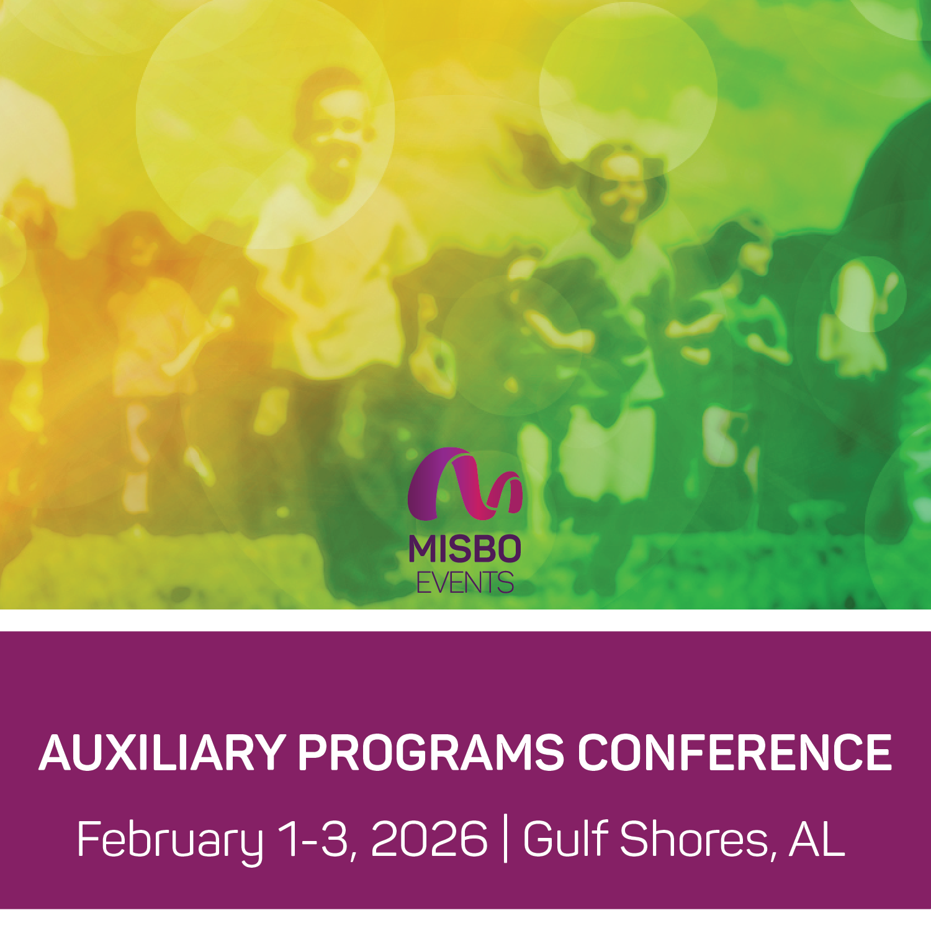
Social Post Ideas
1. Gulf Shores in February? Yes, please. 🌴 Join us for #MISBOAPC26, Feb 1–3, where we’ll talk aftercare, summer camps, and all the things that keep schools running long after the bell. (Bonus: ocean views.) misbo.com/Aux26

2. Who says auxiliary programs are ‘extra’? Spoiler alert: they’re the secret sauce to making schools thrive. 🍔 Catch me at #MISBOAPC26 in Gulf Shores, Feb 1–3. misbo.com/Aux26

3. Sun, sand, and school strategy — #MISBOAPC26 has it all. 🌊 Join us Feb 1–3 in Gulf Shores to rethink after-school, summer programs, and everything in between. misbo.com/Aux26
4. Auxiliary programs: not just babysitting, folks. They’re growth engines. 🚀 Let’s talk about it at #MISBOAPC26, Feb 1–3 in Gulf Shores. misbo.com/Aux26

5. Forget boring conferences. #MISBOAPC26 = ideas, innovation, and maybe a little beach therapy. 🏖️ Gulf Shores, Feb 1–3. You in? misbo.com/Aux26

6. Forget “extras.” Auxiliary programs are the main character energy your school needs. 🎭 Come find out why at #MISBOAPC26, Feb 1–3 in Gulf Shores. misbo.com/Aux26
7. Let’s be real: aftercare, summer camps, and enrichment are the glue that keeps families sane (and schools thriving). 🧩 We’re diving in at #MISBOAPC26, Feb 1–3. misbo.com/Aux26

8. Spoiler: networking at the beach just hits different. 🌊 Join us in Gulf Shores for #MISBOAPC26, Feb 1–3. Education talk + ocean air = genius ideas. misbo.com/Aux26

9. Auxiliary programs: where the creativity (and sometimes chaos) happens. 🤹 Let’s swap stories and strategies at #MISBOAPC26 in Gulf Shores, Feb 1–3. misbo.com/Aux26

10. Professional growth + beach vibes? Don’t mind if we do. 🏖️ See you at #MISBOAPC26 in Gulf Shores, Feb 1–3. Bring sunscreen and your best auxiliary hacks. misbo.com/Aux26

SAMPLE EMAIL
Subject: Sun, sand, and… auxiliary programs? 🌊
Dear [NAME],
Ready to give your school’s auxiliary programs the glow-up they deserve? Pack your flip-flops and join us February 1–3, 2026, in Gulf Shores, AL for the MISBO Auxiliary Programs Conference. We’ll cover it all: aftercare, summer camps, enrichment, the programs that make life hum before and after the bell rings.
Here’s what’s waiting for you:
• Sessions that actually spark ideas (not nap time).
• Strategies to turn “extras” into essential school wins.
• Networking with brilliant peers, with ocean views as a bonus. 🌴
Don’t snooze on this one. Register now at misbo.com/aux26 and claim your spot seaside.
See you in Gulf Shores,
[Your Name]

