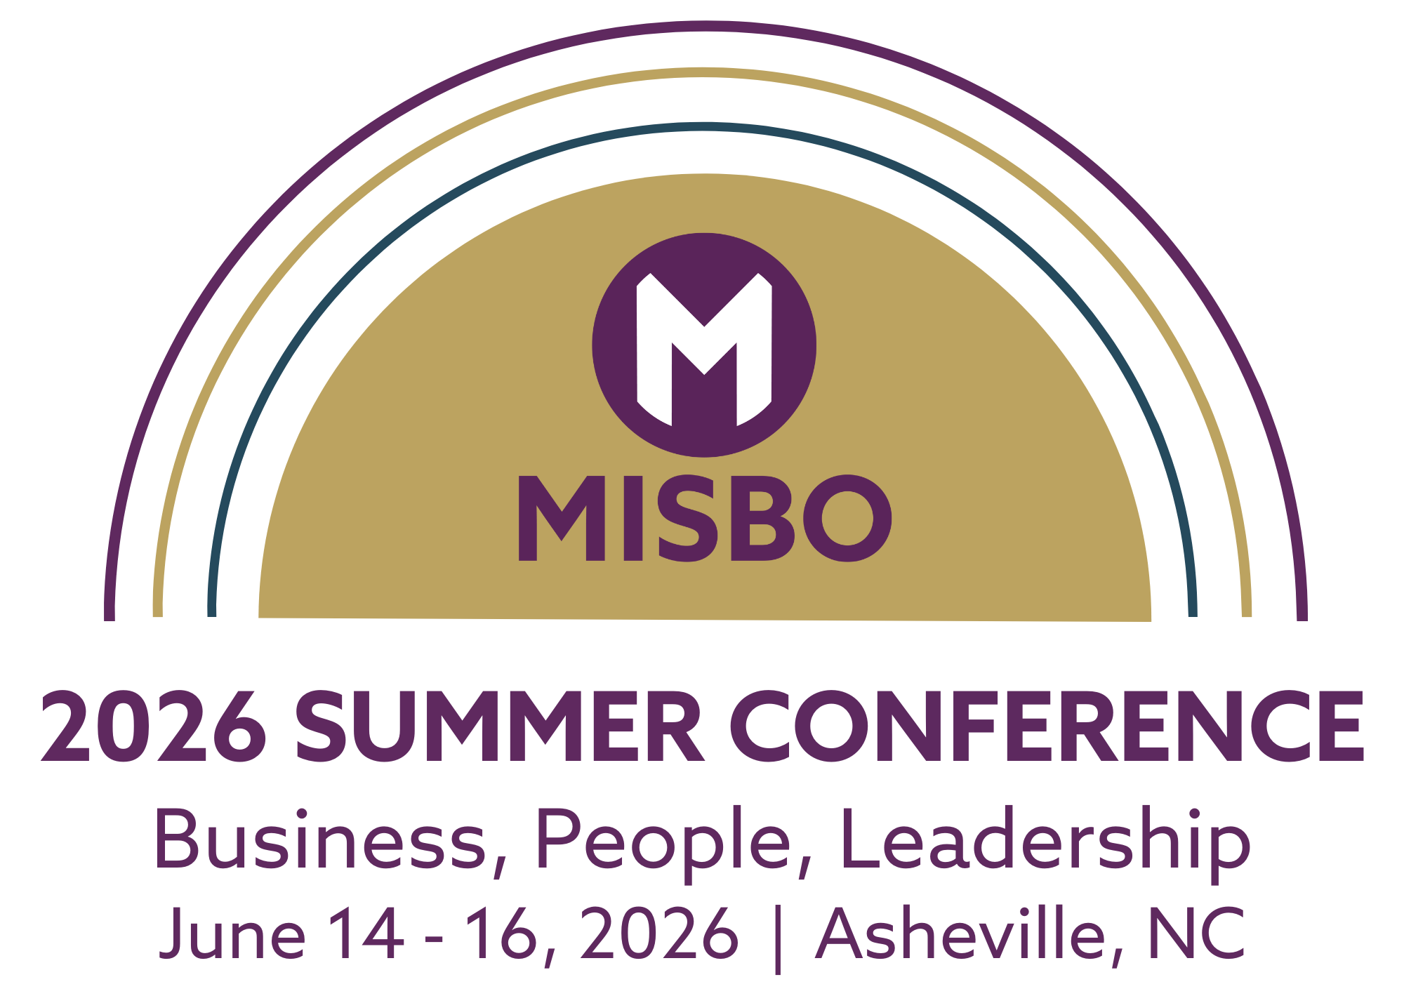

Your support of MISBO is so very important to the success of this event as well as to all MISBO events. We are excited to provide you with this “digital toolkit” which has everything you need to assist in helping to spread the word for a successful conference.
THIS TOOLKIT CONTAINS:
• Event web page
• Best contact information
• Suggested social media copy
• Social media graphic

The best way to use this toolkit is to save it to your desktop along with the event logo. Then you will have everything you need to help spread the word!
Primary Website: misbo.com/2026Summer
This page features all event details as well as the full event schedule with speakers and bios. Also listed are our generous sponsors who support MISBO in numerous ways and deserve attention and awareness. Their participation directly affects registration fees, so we all need to thank them for their support.

Contact information:
Program Content – Kaleigh Smolinski, kaleighsmolinski@misbo.com
Registration – Akshay Anikhindi, akshayanikhindi@misbo.com
Event Logistics – Lisa Flowers, lisaflowers@misbo.com
Sponsors – Susan Kimmel, susankimmel@misbo.com
Social Media Handles:
X, Facebook, and Twitter- @misboconnects | LinkedIn - @misbo
- I’m speaking at the 2026 MISBO Summer Conference: Business, People, Leadership. Come find me in Asheville! misbo.com/2026Summer #MISBO2026 #SchoolLeadership #AshevilleConference
- Catch me at the 2026 MISBO Summer Conference in Asheville for bold conversations and real solutions. misbo.com/2026Summer #BusinessPeopleLeadership #IndependentSchools
- We’re sponsoring the 2026 Summer Conference. Swing by our booth and say hello! misbo.com/2026Summer #SponsorLife #MISBOEvents
- Heading to Asheville for Business, People, Leadership? If you see me, let’s chat strategy. misbo.com/2026Summer #IndySchoolLeaders #ConferenceReady
- I’ll be at the 2026 Summer Conference where decision-makers connect. Join me! misbo.com/2026Summer #SchoolBusiness #LeadershipMatters
- Our team is ready in Asheville at the 2026 MISBO Summer Conference. Stop by our booth! misbo.com/2026Summer #Networking #EducationLeadership
- Speaking on solutions for independent schools at the 2026 MISBO Summer Conference Business, People, Leadership. See you in Asheville! misbo.com/2026Summer #IndependentEducation #ProfessionalGrowth
- Love real conversations and real connections. I’ll be at the 2026 MISBO Summer Conference. misbo.com/2026Summer #MISBOCommunity #SchoolOps
- Sponsoring Business, People, Leadership means we’re here to help your school thrive. Find us onsite in Asheville! misbo.com/2026Summer #ThinkBig #SchoolSuccess
- If you’re at the 2026 Summer Conference, come say hi. I’ll be at booth #XX talking all things impactful. misbo.com/2026Summer #AshevilleNC #EducationStrategies

