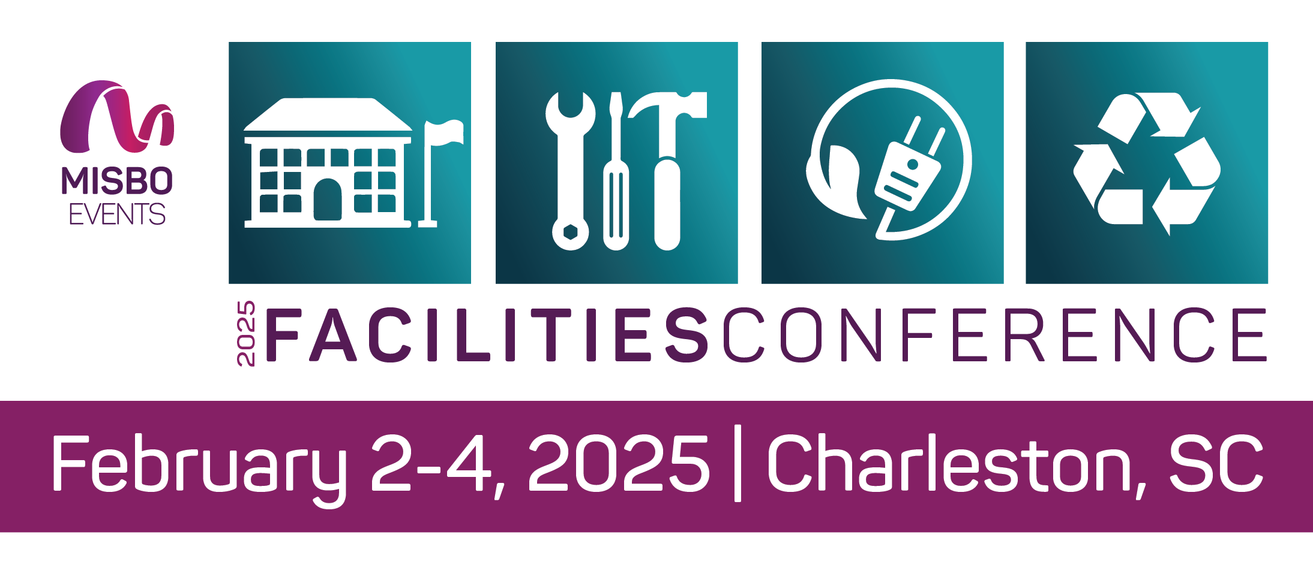
FACILITIES CONFERENCE
February 2-4 | Charleston, SC

Your support of MISBO is so very important to the success of this event as well as to all MISBO events. We are excited to provide you with this “digital toolkit” which has everything you need to assist in helping to spread the word for a successful conference.

THIS TOOLKIT CONTAINS:
• Event web page
• Best contact information
• Suggested social media copy
• Social media graphic

The best way to use this toolkit is to save it to your desktop along with the event logo. Then you will have everything you need to help spread the word!

Primary Website: http://misbo.com/fac25

This page features all event details as well as the full event schedule with speakers and bios. Also listed are our generous sponsors who support MISBO in numerous ways and deserve attention and awareness. Their participation directly affects registration fees, so we all need to thank them for their support.

Contact information:

Program Content – Dianne Sagaas, diannesagaas@misbo.com
Registration – Akshay Anikhindi, akshayanikhindi@misbo.com
Event Logistics – Lisa Flowers, lisaflowers@misbo.com
Sponsors – Dianne Sagaas, diannesagaas@misbo.com
Social Media Graphic
Social Media Handles:
X, Facebook, and Twitter- @misboconnects
LinkedIn - @misbo

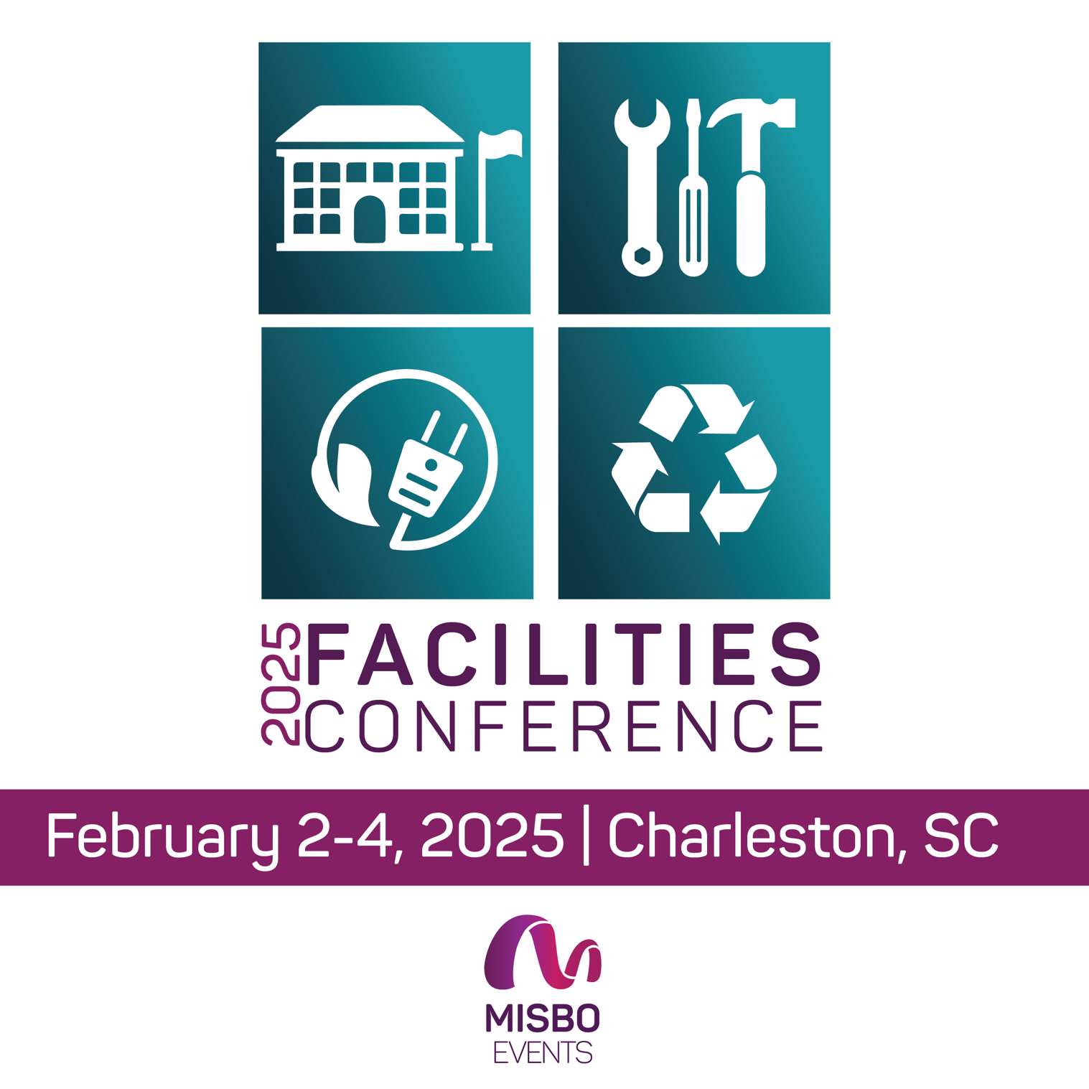
Social Post Ideas
We’re proud to be a [speaker/sponsor] of MISBO's 2025 Facilities Conference, where industry leaders gather to shape the future of #indyschool facility management. Join us to collaborate with like-minded professionals on Feb 2-4 in Charleston, SC. Register: misbo.com/fac25.
I’m honored to share my insights at MISBO's 2025 Facilities Conference in Charleston, SC, Feb 2-4. Let's ignite discussions on elevating #indyschool environments to foster growth and innovation. Looking forward to connecting with fellow thought leaders and shaping the future of education. Sign up: misbo.com/fac25. #MISBOfac25
Join me at MISBO's 2025 Facilities Conference, Feb 2-4 in Charleston, SC, where we'll uncover strategies to enhance #indyschool functionality and sustainability. Let's create spaces that inspire and empower the next generation. Looking forward to engaging discussions and fruitful connections. Learn more: misbo.com/fac25. #MISBOfac25
Elevate your #indyschool operations with us at #MISBOfac25! Excited to showcase game-changing solutions in Charleston, SC, Feb 2-4. See you there! Register – misbo.com/fac25
Ready to explore #indyschool facility trends! Join me at #MISBOFac25, Feb 2-4, Charleston, SC. Let's create inspiring educational spaces together. Learn more – misbo.com/fac25.
Sharing insights at #MISBOfac25! Let's revolutionize #indyschool environments in Charleston, SC, Feb 2-4. Connect, collaborate, and innovate with us – misbo.com/fac25.
Join the conversation at #MISBOFac25, Feb 2-4, Charleston, SC. Let's uncover sustainable #indyschool solutions and empower future generations. Sign up – misbo.com/fac25.

SAMPLE EMAIL
[Name],
Are you ready to elevate your school's facilities management? Join us at the 2025 MISBO Facilities Conference in Charleston, SC!
Date: February 2-4, 2025
Location: Charleston, SC
Register: misbo.com/fac25
Hashtag: #MISBOFac25
Connect with industry experts, explore the latest strategies, and discover innovative solutions to enhance your school's environment. From sustainability to security, our conference covers it all.
Don't miss this chance to optimize your school's facilities. Register now and be part of the future of independent school facility management!
See you in Charleston!
Warm regards,
[Your Name]

