

Welcome to Your 2025 Pathway to Leadership:
Finance & Operations Toolkit!
We’re thrilled to have you as part of this incredible event! Whether you’re a speaker or sponsor, we want to make it easy for you to spread the word and maximize your impact. Below, you’ll find pre-written social media posts designed to help you engage your audience, build excitement, and encourage others to join us.
Simply copy, paste, and personalize these posts to fit your style—and don’t forget to include the event hashtag #MISBOPLFO25 to keep the conversation going!
Primary Website: www.misbo.com/plfo25
Contact information:
Program Content – Dianne Sagaas, diannesagaas@misbo.com
Registration – Akshay Anikhindi, akshayanikhini@misbo.com
Event Logistics – Lisa Flowers, lisaflowers@misbo.com
Sponsors – Dianne Sagaas, diannesagaas@misbo.com

CONFERENCE LOGO:
(right-click on the image and choose “Save Image As”/”Save As Picture”
to save locally to your computer)

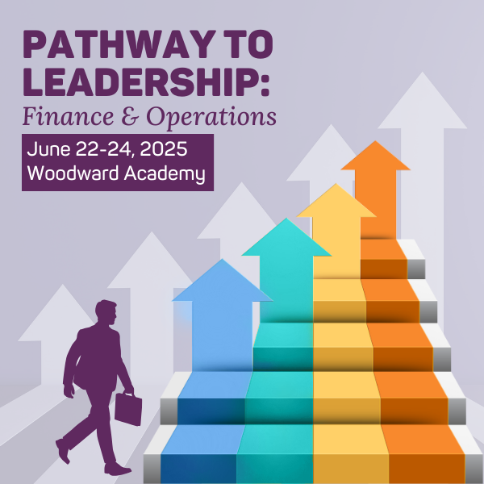

SOCIAL MEDIA RESOURCES

LinkedIn: Find Us Here
Twitter: @MISBOConnects
Facebook: @MISBOConnects
Instagram: @MISBOConnects
Social Media Hashtag: #PathwayFIN25

SUGGESTED POSTS FOR SPEAKERS
- 🔝 New to independent schools or the business office? MISBO’s Pathway to Leadership: Finance & Operations equips you with essential skills to succeed! Register now: www.misbo.com/plfo25 #PathwayFIN25
- 💡 Stepping into a finance or operations role? Gain the fundamentals of nonprofit accounting, budgeting & school operations at MISBO’s Pathway to Leadership! Sign up today: www.misbo.com/plfo25 #PathwayFIN25
- 🚀 Aspiring CFOs & Business Officers—this is your launchpad! Master budgeting, HR, facilities & more at MISBO’s Pathway to Leadership: Finance & Operations. Join us! www.misbo.com/plfo25 #PathwayFIN25
- 🏆 Build a strong foundation for your leadership journey! Learn the essentials of school finance & operations at MISBO’s Pathway to Leadership. Advance your career—register today! www.misbo.com/plfo25 #PathwayFIN25
- 💼 New to school finance & operations? Get the tools & knowledge to thrive in your role at MISBO’s Pathway to Leadership. Secure your spot now! www.misbo.com/plfo25 #PathwayFIN25

SUGGESTED POSTS FOR SPONSORS
- 🔝 Investing in future CFOs & Business Officers! We’re proud sponsors of MISBO’s Pathway to Leadership—stop by our booth & let’s talk career growth! Register now: www.misbo.com/plfo25 #PathwayFIN25
- 🚀 The next generation of school finance leaders starts here! We’re excited to sponsor MISBO’s Pathway to Leadership—let’s connect & support your journey. Sign up today! www.misbo.com/plfo25 #PathwayFIN25
- 🌟 Leadership + Innovation = Career Growth! We’re thrilled to support MISBO’s Pathway to Leadership, where aspiring CFOs & Business Officers gain key skills. Register today! www.misbo.com/plfo25 #PathwayFIN25
- 📚 Supporting the next wave of school finance leaders! We’re proud to sponsor MISBO’s Pathway to Leadership—helping professionals like you grow & lead. Secure your spot now! www.misbo.com/plfo25 #PathwayFIN25
- 🛠️ Strong leaders need the right tools! We’re excited to be part of MISBO’s Pathway to Leadership, where finance & ops professionals gain game-changing insights. Don’t miss out—register today! www.misbo.com/plfo25 #PathwayFIN25

EMAIL COPY FOR SPEAKERS & SPONSORS
Subject: Join Me at MISBO’s 2025 Pathway to Leadership Event!
Hi [Name],
I hope you're doing well! I wanted to personally invite you to MISBO’s 2025 Pathway to Leadership event—an essential gathering for independent school leaders looking to elevate their skills, connect with industry experts, and explore new strategies for success.
I’ll be [speaking/sponsoring] at this event, and I’d love for you to be there too! It’s the perfect opportunity to gain fresh perspectives, network with like-minded professionals, and take your leadership to the next level.
Event Details:
- What: MISBO’s 2025 Pathway to Leadership Event
- When: June 22-24, 2025
- Where: Woodward Academy, Atlanta, GA
- Register Here: www.misbo.com/plfo25
Don’t miss out on this incredible opportunity to engage with the best in independent school leadership. Feel free to reach out if you have any questions—I hope to see you there!
Best, [Your Name]
[Your Contact Information]

