

Welcome to Your 2025 MISBO HR Intensive Marketing Toolkit!
We’re thrilled to have you as part of this incredible event! Whether you’re a speaker or sponsor, we want to make it easy for you to spread the word and maximize your impact. Below, you’ll find pre-written social media posts designed to help you engage your audience, build excitement, and encourage others to join us.
Simply copy, paste, and personalize these posts to fit your style—and don’t forget to include the event hashtag #MISBOHRI25 to keep the conversation going!
Primary Website: misbo.com/hri25
Contact information:
Program Content – Dianne Sagaas, diannesagaas@misbo.com
Registration – Akshay Anikhindi, akshayanikhini@misbo.com
Event Logistics – Lisa Flowers, lisaflowers@misbo.com
Sponsors – Dianne Sagaas, diannesagaas@misbo.com

CONFERENCE LOGO:
(right-click on the image and choose “Save Image As”/”Save As Picture”
to save locally to your computer)

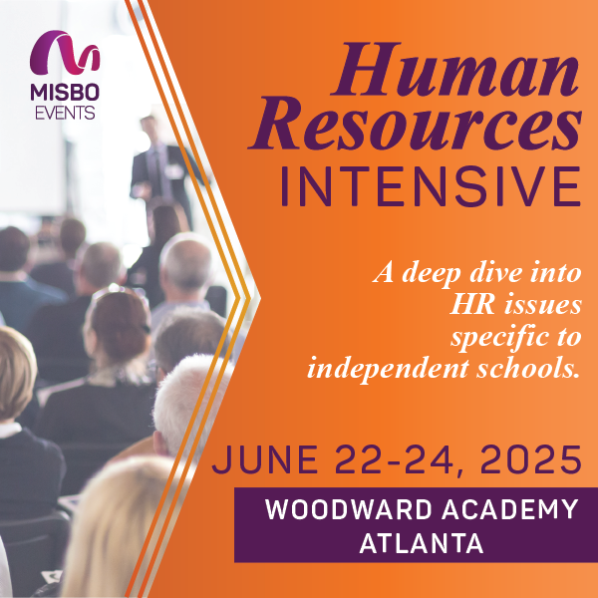
SOCIAL MEDIA RESOURCES

LinkedIn: Find Us Here
Twitter: @MISBOConnects
Facebook: @MISBOConnects
Instagram: @MISBOConnects
Social Media Hashtag: #MISBOHRI25

SUGGESTED POSTS FOR SPEAKERS
- 🚀 Ready to elevate your HR career? Join me at MISBO’s 2025 Human Resources Intensive—where insights meet impact! I’ll be sharing top strategies and fresh perspectives you won’t want to miss. Secure your spot now at misbo.com/hri25. Let’s make HR magic happen! #MISBOHRI25
- HR pros, unite! If you’re part of the #indyschool HR community, this is the event to attend. I’ll be there alongside industry experts, diving into cutting-edge HR strategies. Register today at misbo.com/hri25! #MISBOHRI25
- Big news! 🎉 I’ll be speaking at MISBO’s 2025 Human Resources Intensive, and I want you to join me! Let’s connect, learn, and have a little fun while we’re at it. Register now at misbo.com/hri25. #MISBOHRI25
- Calling all HR rockstars! 🎤 Get ready for expert insights, invaluable networking, and strategies that will level up your HR game. Reserve your spot now at misbo.com/hri25 and be part of the action! #MISBOHRI25
- HR leaders—this one’s for you! 💼 Join me at MISBO’s 2025 Human Resources Intensive as we explore the latest trends and best practices shaping our field. Let’s empower ourselves and our teams for success. Register now at misbo.com/hri25. See you there! #MISBOHRI25

SUGGESTED POSTS FOR SPONSORS
- HR professionals, we see you! Swing by our table at MISBO's 2025 Human Resources Intensive to chat about innovative HR solutions. Let’s shake hands, brainstorm, and build success together! Register now at misbo.com/hri25. #MISBOHRI25
- Level up your HR strategy! We’re bringing cutting-edge solutions to MISBO's 2025 Human Resources Intensive. Let’s connect and explore how we can help your organization thrive. Register at misbo.com/hri25. #MISBOHRI25
- We’re thrilled to be sponsoring MISBO's HR Intensives! If you haven’t registered yet, what are you waiting for? Come meet us and explore the future of HR! Sign up now at misbo.com/hri25. #MISBOHRI25
- HR pros + game-changing solutions = the perfect match. As proud sponsors of MISBO's 2025 HR Intensive, we’re here to help you navigate the ever-changing HR landscape. Secure your spot now at misbo.com/hri25. #MISBOHRI25
- We’re sponsoring MISBO's HR Intensives! Join us for expert insights, networking, and tools to elevate your HR practice. Let’s make connections that last! Register today at misbo.com/hri25. #MISBOHRI25

EMAIL COPY FOR SPEAKERS & SPONSORS
Subject: Join Me at MISBO’s 2025 Human Resources Intensive!
Hi [Name],
I hope you're doing well! I wanted to personally invite you to MISBO’s 2025 Human Resources Intensive, happening soon! This is a must-attend event for independent school HR professionals who want to gain fresh insights, connect with industry leaders, and discover the latest strategies for success.
I’ll be [speaking/sponsoring] at this event, and I’d love for you to be there too! It’s the perfect opportunity to learn, network, and take your HR expertise to the next level.
Event Details:
- What: MISBO’s 2025 Human Resources Intensive
- When: June 22-24, 2025
- Where: Woodward Academy in Atlanta, GA
- Register Here: misbo.com/hri25
Don’t miss out on this amazing opportunity to connect with fellow HR professionals. Feel free to reach out if you have any questions—I hope to see you there!

