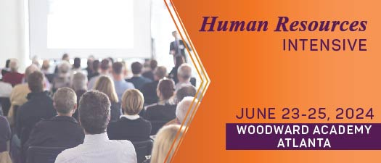

Your support is vital to the success of MISBO's upcoming Summer Intensives in June!
We've got your back with this handy "toolkit" that contains all the goodies to help you spread the word.
Pro tip: save it to your desktop along with the event logo, and you'll have everything you need to be a rockstar in spreading the word!

Primary Website: misbo.com/hri24

Contact information:

Program Content – Dianne Sagaas, diannesagaas@misbo.com
Registration – Akshay Anikhindi, akshayanikhini@misbo.com
Event Logistics – Lisa Flowers lisaflowers@misbo.com
Sponsors – Dianne Sagaas, diannesagaas@misbo.com

CONFERENCE LOGO:
(right-click on the image and choose “Save Image As”/”Save As Picture”
to save locally to your computer)

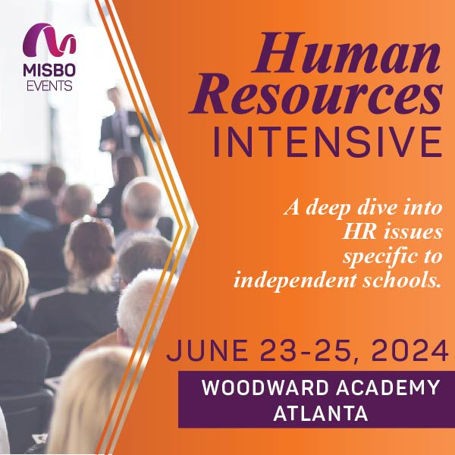
SOCIAL MEDIA RESOURCES

LinkedIn: Find Us Here
Twitter: @MISBOConnects
Facebook: @MISBOConnects
Instagram: @MISBOConnects
Social Media Hashtag: #MISBOHRI24

SUGGESTED POSTS FOR SPEAKERS:
- Ready to take your HR career to new heights? Join me at MISBO's 2024 Human Resources Intensive. I’ll be speaking and I have an incredible message planned. Secure your spot now at misbo.com/hri24. Don't miss out! #MISBOHRI24
- Calling all #indyschool HR professionals! Discover the unique experience of MISBO's 2024 Human Resources Intensive with me and other experts. Let's dive into tailored insights together. Register today at misbo.com/hri24. #MISBOHRI24
- Exciting news! I'll be speaking at MISBO's 2024 Human Resources Intensive, and I want you to join me! Let's collaborate, learn, and network together at this enriching event. Register now at misbo.com/hri24. #MISBOHRI24
- Thrilled to be part of MISBO's 2024 Human Resources Intensive! Join me for insightful discussions, valuable networking, and a chance to enhance your HR expertise. Reserve your spot now at misbo.com/hri24. Let's make this event unforgettable! #MISBOHRI24
- 📢 Calling all HR leaders! Join me at MISBO's 2024 Human Resources Intensive for a deep dive into the latest trends and best practices. Let's empower ourselves and our teams for success. Register today at misbo.com/hri24. Can't wait to see you there! #MISBOHRI24

SUGGESTED POSTS FOR SPONSORS:

- Seeking innovative HR solutions? Swing by our table at MISBO's 2024 Human Resources Intensive! Let's shake hands, discuss your needs, and explore partnership opportunities. Register - misbo.com/hri24. #MISBOHRI24
- Ready to take your HR strategies to the next level? Meet us at MISBO's 2024 Human Resources Intensive and discover how our solutions can drive success for your organization. misbo.com/hri24 #MISBOHRI24
- We're thrilled to be sponsoring MISBO's HR Intensives! If you haven't registered yet, now's the time. We're eager to connect with you. Visit misbo.com/hri24 to secure your spot. See you there! #MISBOHRI24
- As sponsors of MISBO's HR Intensives, we're excited to contribute to your professional development. Join us for a day of learning and networking. Secure your spot now at misbo.com/hri24. Let's build connections that last! #MISBOHRI24
- Join us as we sponsor MISBO's HR Intensives - the premier event for HR professionals. Secure your spot now at misbo.com/hri24 and gain valuable insights to propel your career forward. See you there! #MISBOHRI24

