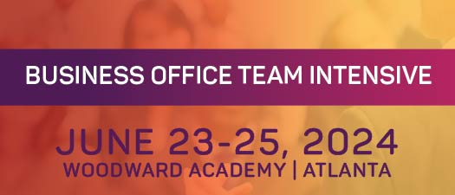

Your support is vital to the success of MISBO's upcoming Summer Intensives in June!
We've got your back with this handy "toolkit" that contains all the goodies to help you spread the word.
Pro tip: save it to your desktop along with the event logo, and you'll have everything you need to be a rockstar in spreading the word!

Primary Website: misbo.com/boti24

Contact information:
Program Content – Dianne Sagaas, diannesagaas@misbo.com
Registration – Akshay Anikhindi, akshayanikhini@misbo.com
Event Logistics – Lisa Flowers lisaflowers@misbo.com
Sponsors – Dianne Sagaas, diannesagaas@misbo.com

CONFERENCE LOGO:
(right-click on the image and choose “Save Image As”/”Save As Picture”
to save locally to your computer)
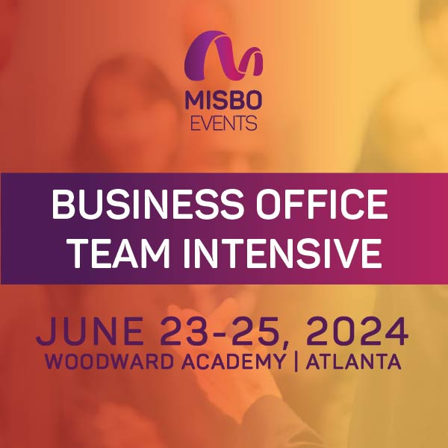

SOCIAL MEDIA RESOURCES

LinkedIn: Find Us Here
Twitter: @MISBOConnects
Facebook: @MISBOConnects
Instagram: @MISBOConnects
Social Media Hashtag: #MISBOBOTI24

SUGGESTED POSTS FOR SPEAKERS:

- 🌟 I’m excited to speak at MISBO's 2024 Business Office Team Intensive! Join me for insights and networking. Register at misbo.com/boti24. #MISBOBOTI24
- #Indyschools - Don't miss me at MISBO's 2024 Business Office Team Intensive! Register now at misbo.com/boti24 for industry strategies. #MISBOBOTI24
- Join me at MISBO's 2024 Business Office Team Intensive for expert insights! Register at misbo.com/boti24. #MISBOBOTI24
- Thrilled to be attending and speaking at MISBO's 2024 Business Office Team Intensive! Join us at misbo.com/boti24. #MISBOBOTI24
- I’m counting down the days until #MISBOBOTI24. Ready to join me for a conference full of inspiration, knowledge sharing, and fun? Reserve your spot now at misbo.com/boti24.

SUGGESTED POSTS FOR SPONSORS:

- Attention Business Officers, Controllers, and Benefits Administrators! I'm thrilled to sponsor MISBO's 2024 Business Office Team Intensive. Join me for a day of learning and networking. Register now at misbo.com/boti24! #MISBOBOTI24
- I'm excited to sponsor MISBO's 2024 Business Office Team Intensive - an event that's informative, engaging, and fun! Join me for tailored sessions relevant to independent school business office teams Register at misbo.com/boti24 and let's grow together! #MISBOBOTI24
- As a sponsor of MISBO's 2024 Business Office Team Intensive, I'm excited to contribute to the professional development of #indyschool professionals. Join me for a day of learning and networking. Register now at misbo.com/boti24 and let's excel together! #MISBOBOTI24
- Thrilled to support #MISBOBOTI24, the ultimate gathering for Business Office Teams at #indyschools. Don’t miss this chance to gain valuable insights, forge new connections, and accelerate your career. Register at misbo.com/boti24.
- I am proud to sponsor #MISBOBOTI24, a must-attend event for #indyschool professionals looking to stay ahead in their field. Secure your spot now to join us at misbo.com/boti24.

