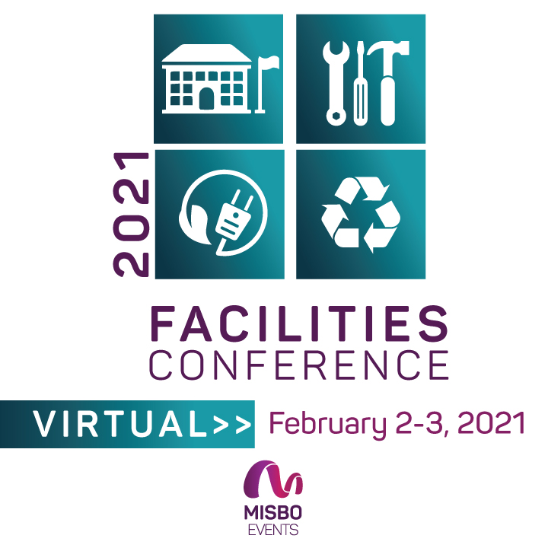

**2021 MISBO** **FACILITIES CONFERENCE**

February 2-3, 2021 | VIRTUAL

Your support of **MISBO** is so very important to the success of this event as well as to all **MISBO** events. We are excited to provide you with this “digital toolkit” which has everything you need to assist in helping to spread the word for a successful conference.

**This Toolkit Contains:**

* Event **Web Page**
* “**Best Contact**” information
* Suggested **social media** posts for your use
* Event **logos**

*The best way to use this toolkit is to save it to your desktop along with the event logo. Then you will have everything you need to help spread the word!*

**Primary Website:** [www.**misbo.com/fac21**](http://www.misbo.com/fac21)

This page features all event details as well as the full event schedule with speakers and bios. Also listed are our generous sponsors who support **MISBO** in numerous ways and deserve attention and awareness. Their participation directly affects registration fees so we all need to thank them for their support.

**Contact information:**

**Program Content** – Dianne Sagaas, diannesagaas@misbo.com

**Registration** – Cheryl Goode, [cherylgoode@misbo.com](mailto:cherylgoode@misbo.com)

**Event Logistics** – Lindsay Cuppia, [lindsaycuppia@misbo.com](mailto:lindsaycuppia@misbo.com)

**Sponsors** – Dianne Sagaas, [diannesagaas@misbo.com](mailto:diannesagaas@misbo.com)

**EVENT LOGO:**

**SOCIAL MEDIA RESOURCES**

**MISBO Twitter Handle:** @MISBOConnects

**Facebook**: MISBO

**Instagram:** MISBOConnects

**Social Media Hashtag:** #MISBOFac21

**SUGGESTED POSTS** (less than 280 characters to be tweetable; use the event logo with all posts; @tags for twitter only):

* Facilities Directors... we've got a VIRTUAL conference just for you! Mark your calendar for Feb. 2-3 and register today for the @misboconnects 2021 Facilities Conference! [www.misbo.com/fac21](http://www.misbo.com/fac21) #MISBOFac21
* Facilities Directors... this one's for you. 2021 @misboconnects VIRTUAL Facilities Conference. February 2-3, 2021. Register today. misbo.com/fac21 #MISBOFac21
* Facility Directors...gather valuable information to help you perform the daily tasks critical to your #indyschool's smooth & successful operation... without leaving your DESK! Register today for @misboconnects VIRTUAL #MISBOFac21 in February. misbo.com/fac21
* "How Building Automation, Logistics, and Communications Create Successful Programs"… join @misboconnects VIRTUALLY at #MISBOFac21 for this and so much more. [www.misbo.com/fac21](http://www.misbo.com/fac21)
* Planning an #indyschool reno? Delve into Renovations 101 at #MISBOFac21 so you can learn how to manage a successful construction project on a K-12 campus. REGISTER TODAY! [www.misbo.com/fac21](http://www.misbo.com/fac21)
* Facilities Directors… learn the art of space planning for the evolving #indyschool classroom. Join @misboconnects virtually for #MISBOFac21 in February. Registration now open: [www.misbo.com/fac21](http://www.misbo.com/fac21)
* Sometimes partnerships work…sometimes they don’t. Learn how to have a successful design partner for your next #indyschool construction project. #MISBOFac21 is virtual in February! [www.misbo.com/fac21](http://www.misbo.com/fac21)
* Facilities Directors… listen up! Do you know how to plan for asset reserves? Attend the VIRTUAL @misboconnects Facilities Conference in February to find out more. Register at [www.misbo.com/fac21](http://www.misbo.com/fac21) #MISBOFac21
* A conference for the unsung heroes of #indyschools. Facilities folks, join @misboconnects VIRTUALLY for #MISBOFac21 in February. REGISTRATION NOW OPEN! [www.misbo.com/fac21](http://www.misbo.com/fac21)

**LONGER LINKED-IN SUGGESTED POSTS:**

* The 2021 VIRTUAL MISBO Facilities Conference is designed for independent school facilities directors and the administrators they work with. Sessions include: Planning for long-range asset reserves; Building automation and logistics; Managing renovation and construction projects. #MISBOFac21 [www.misbo.com/fac21](http://www.misbo.com/fac21)
* Facility Directors... gather valuable information to help you perform the daily tasks critical to your #indyschool's smooth and successful operation... without leaving your DESK! Register today for the VIRTUAL #MISBOFac21 in February. [www.misbo.com/fac21](http://www.misbo.com/fac21)
* Who should attend MISBO’s VIRTUAL Facilities Conference in February? Facilities/Operations Directors, Facilities Managers, Facilities Support Staff, Business Officers, and other administrators who manage/work with facilities departments. Register today at [www.misbo.com/fac21](http://www.misbo.com/fac21) #MISBOFac21