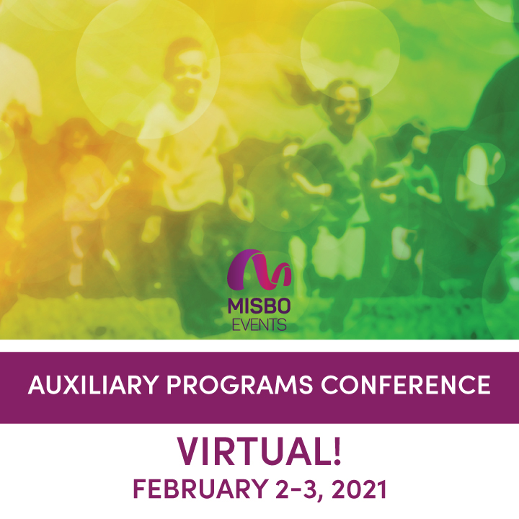

**2021 MISBO AUXILIARY PROGRAMS CONFERENCE**

February 2-3, 2021 | VIRTUAL

Your support of **MISBO** is so very important to the success of this event as well as to all **MISBO** events. We are excited to provide you with this “digital toolkit” which has everything you need to assist in helping to spread the word for a successful conference.

**This Toolkit Contains:**

* Event **Web Page**
* “**Best Contact**” information
* Suggested **social media** posts for your use
* Event **logos**

*The best way to use this toolkit is to save it to your desktop along with the event logo. Then you will have everything you need to help spread the word!*

**Primary Website:** [www.misbo.com/apc21](http://www.misbo.com/apc21)

This page features all event details as well as the full event schedule with speakers and bios. Also listed are our generous sponsors who support **MISBO** in numerous ways and deserve attention and awareness. Their participation directly affects registration fees so we all need to thank them for their support.

**Contact information:**

**Program Content** – Dianne Sagaas, diannesagaas@misbo.com

**Registration** – Cheryl Goode, [cherylgoode@misbo.com](mailto:cherylgoode@misbo.com)

**Event Logistics** – Lindsay Cuppia, [lindsaycuppia@misbo.com](mailto:lindsaycuppia@misbo.com)

**Sponsors** – Dianne Sagaas, [diannesagaas@misbo.com](mailto:diannesagaas@misbo.com)

**EVENT LOGO:**



**SOCIAL MEDIA RESOURCES**

**MISBO Twitter Handle:** @MISBOConnects

**Facebook**: MISBO

**Instagram:** MISBOConnects

**Social Media Hashtag:** #MISBOAPC21

**SUGGESTED POSTS** (less than 280 characters to be tweetable; use the event logo with all posts; @tags for twitter only):

* AUXILIARY DIRECTORS don't dodge this conference! Network VIRTUALLY at #MISBOAPC21 in February... PD, networking, and an exchange of ideas for those that manage auxiliary programs. REGISTRATION NOW OPEN! [www.misbo.com/apc21](http://www.misbo.com/apc21)
* Stay calm Auxiliary Directors! @misboconnects has a conference dedicated just to you and the unique role you serve in #indyschools. Join me VIRTUALLY in February for 2021 Auxiliary Programs Conference. Registration now open! [www.misbo.com/apc21](http://www.misbo.com/apc21) #MISBOAPC21
* VIRTUAL #MISBOAPC21... coming soon to a computer near you. REGISTER TODAY! [www.misbo.com/apc21](http://www.misbo.com/apc21)
* Optimize your Auxiliary Program marketing efforts…. @misboconnects and @829studios will teach you how. Join me virtually at #MISBOAPC21. REGISTER TODAY! [www.misbo.com/apc21](http://www.misbo.com/apc21)
* Safety plans for all auxiliary programs in #indyschools… if you haven’t fine-tuned yours yet, now’s the time. Join me virtually in February at #MISBOAPC21. REGISTRATION NOW OPEN. [www.misbo.com/apc21](http://www.misbo.com/apc21)
* Got school spirit? I do! Learn New Strategies to Enhance Your School Store in Normal and COVID Times during @misboconnects 2021 Auxiliary Programs Conference in February. Join me virtually! [www.misbo.com/apc21](http://www.misbo.com/apc21)
* Auxiliary Programs, like many #indyschool programs, relies on digital marketing for successful community engagement. @misboconnects #MISBOAPC21 will teach you how to in-house your SEO efforts for top-notch marketing efforts. [www.misbo.com/apc21](http://www.misbo.com/apc21)
* Delivering Quality In-Person Programming While Managing a Flexible Budget… it’s the #1 goal for all #indyschool Auxiliary Directors. Join me virtually at #MISBOAPC21 to find out how! [www.misbo.com/apc21](http://www.misbo.com/apc21)

**LONGER LINKED-IN SUGGESTED POSTS:**

* MISBO’s 2021 Auxiliary Programs Conference is for all things before and after the bells ring. After care, extended days, summer camp, and enrichment programs are all important to the school community. Offerings outside the classroom can mean additional revenue for the school, much needed childcare for parents, and exposure to a variety of activities for students. This virtual conference will offer professional development, networking opportunities, and an exchange of ideas for those who work with auxiliary programs in independent schools. February 2-3. Register today at [www.misbo.com/apc21](http://www.misbo.com/apc21)
* Join me VIRTUALLY in February for MISBO’s 2021 Auxiliary Programs Conference. SESSION TOPICS INCLUDE: How to optimize your marketing efforts; Safety plans; Enhancing your school store; How to run a successful CIT program …. and more! Auxiliary Programs Directors, After School Directors, Summer Programs Directors, and Camp Directors – REGISTER TODAY! [www.misbo.com/apc21](http://www.misbo.com/apc21)