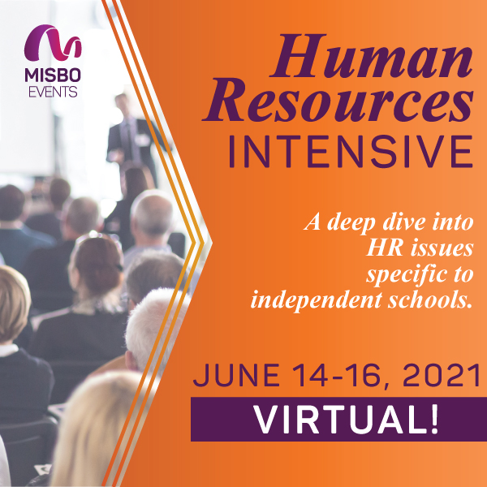

Your support of **MISBO** is so very important to the success of this event as well as to all **MISBO** events. We are excited to provide you with this promotional toolkit, which has everything you need to assist in helping to spread the word for a successful event in June.

*The best way to use this toolkit is to save it to your desktop along with the event logo. Then you will have everything you need to help spread the word!*

**Primary Website:** [www.misbo.com/HRI21](http://www.misbo.com/HRI212)

**Contact information:**

**Program Content** – Dianne Sagaas, diannesagaas@misbo.com

**Registration** – Cheryl Goode, [cherylgoode@misbo.com](mailto:cherylgoode@misbo.com)

**Event Logistics** – Lindsay Cuppia, [lindsaycuppia@misbo.com](mailto:lindsaycuppia@misbo.com)

**Sponsors** – Dianne Sagaas, diannesagaas@misbo.com

**CONFERENCE LOGO:**

(right-click on the image and choose “Save Image As”/”Save As Picture” to save locally to your computer)



**SOCIAL MEDIA RESOURCES**

**MISBO Twitter Handle:** @MISBOConnects

**Facebook**: MISBO

**Instagram:** MISBOConnects

**Social Media Hashtag:** #MISBOHRI21

**SUGGESTED POSTS** (less than 280 characters to be tweetable; use the event logo with all posts; @tags for twitter only):

* The Anatomy of Happy, High-Functioning Teams… Deep dive virtually during MISBO’s 2021 Human Resources Intensive. Register today at misbo.com/hri21. #MISBOHRI21
* Preparing The Employee Handbook In a Post-Pandemic World during MISBO’s HR Intensive in June. Topics will include addressing social and political conversation, LGBTQ influenced policies, and numerous pandemic-related updates. Register today at misbo.com/hri21. #MISBOHRI21
* School heads are recognizing the importance of shifting HR from a compliance-based necessity to being a partner in achieving strategic goals. Explore 5 effective ways HR can elevate their voice and value throughout their #indyschool during #MISBOHRI21. misbo.com/hri21
* #indyschools must protect their students from sexual abuse. Whether your school is currently navigating an allegation, encountered one before, or is refining its crisis response plan… Deep dive during #MISBOHRI21. misbo.com/hri21
* Ethics in #indyschools… hear case studies involving scenarios where individuals or teams were required to make difficult decisions based on the ethical response. Virtually in June during #MISBOHRI21. misbo.com/HRI21

**LONGER LINKED-IN SUGGESTED POSTS:**

* Human resources should be designed to help achieve the goals and business objectives of an organization, and a school is no exception. The independent school HR professional does this through excellent communications and use of efficient processes, while supporting a sustainable information security and privacy strategy. This will add value, assist in making your school more competitive, and allow you to become a strategic partner. Join a 3-day virtual conference with your colleagues to deep dive into the hot-topic HR issues affecting #indyschools. #MISBOHRI21… register at misbo.com/hri21
* MISBO’s 2021 Human Resources Intensive… Build your own skills and that of your team while you collaborate and share with your peers, leaving with valuable takeaways to assist you in the daily tasks that are critical to the success of your school. Register today at misbo.com/hri21. #MISBOHRI21
* Back by popular demand! MISBO’s 2021 Human Resources Intensive is the only one of its kind. This program provides collaboration opportunities and valuable sessions specifically designed for HR professionals in independent schools. Registration now open… misbo.com/hri21. #MISBOHRI21