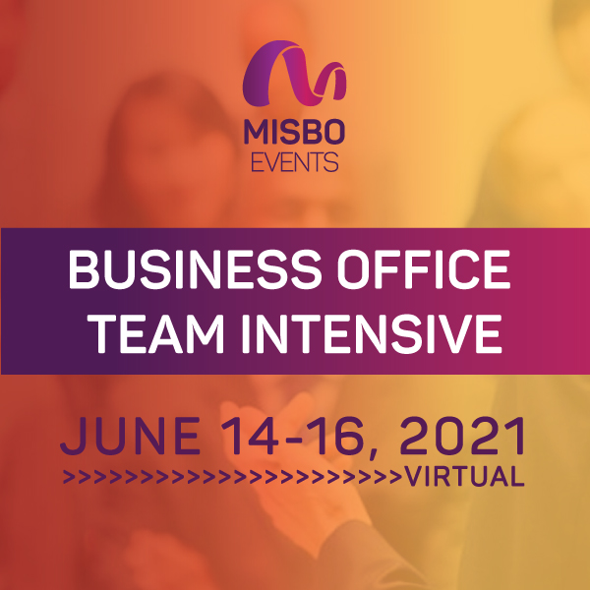

Your support of **MISBO** is so very important to the success of this event as well as to all **MISBO** events. We are excited to provide you with this promotional toolkit, which has everything you need to assist in helping to spread the word for a successful event in June.

*The best way to use this toolkit is to save it to your desktop along with the event logo. Then you will have everything you need to help spread the word!*

**Primary Website:** [www.misbo.com/boti21](http://www.misbo.com/boti21)

**Contact information:**

**Program Content** – Dianne Sagaas, diannesagaas@misbo.com

**Registration** – Cheryl Goode, [cherylgoode@misbo.com](mailto:cherylgoode@misbo.com)

**Event Logistics** – Lindsay Cuppia, [lindsaycuppia@misbo.com](mailto:lindsaycuppia@misbo.com)

**Sponsors** – Dianne Sagaas, diannesagaas@misbo.com

**CONFERENCE LOGO:**

(right-click on the image and choose “Save Image As”/”Save As Picture” to save locally to your computer)



**SOCIAL MEDIA RESOURCES**

**MISBO Twitter Handle:** @MISBOConnects

**Facebook**: MISBO

**Instagram:** MISBOConnects

**Social Media Hashtag:** #MISBOBOTI21

**SUGGESTED POSTS** (less than 280 characters to be tweetable; use the event logo with all posts; @tags for twitter only):

* MISBO’s 2021 Business Office Team Intensive… #indyschools will get the most from this event with their entire business office team in attendance, whether it is a team of one or ten! misbo.com/boti21 #MISBOBOTI21
* The Anatomy of Happy, High-Functioning Teams… a must-have for all #indyschool business offices to succeed. Deep dive virtually during #MISBOBOTI21… register your entire business office team: misbo.com/boti21
* While teams are as varied, complex, and unique as the people on them, they often face similar challenges and opportunities. During #MISBOBOTI21 discuss relationship building, collaboration, empathy, and communication. Register today at misbo.com/boti21
* So, You Want to Prepare a Records Management & Retention Plan… attend the virtual #MISBOBOTI21 to get started. Registration now open at misbo.com/boti21
* The #indyschool business office tracks and tells a financial story through effective reporting and information sharing. Learn how to structure your chart of accounts to enhance your reporting and storytelling during #MISBOBOTI21. misbo.com/boti21
* The Expectation of Privacy - HIPPA, Unauthorized Disclosures, and More… during MISBO’s 2021 Business Office Team Intensive. Register your entire team today at misbo.com/boti21
* Ethics in #indyschools… hear case studies involving scenarios where individuals or teams were required to make difficult decisions based on the ethical response. Virtually in June during #MISBOBOTI21. misbo.com/boti21
* Improper disclosure of private information can result in claims against your #indyschool or employees. Learn the many ways disclosures occur and how to best protect the school, train the community, and monitor areas of concern. #MISBOBOTI21. misbo.com/boti21
* The chart of accounts is fundamental to accounting and financial reporting and many #indyschools have not given theirs enough attention, particularly since FASB reporting standards changed for the first time in 20 years. Join us for #MISBOBOTI21. misbo.com/boti21
* During #MISBOBOTI21, gain more insight into the Truth In Lending Act (TILA), Know Your Customer (KYC) rules, the Bank Secrecy Act (BSA), applicable NACHA rules, card acceptance rules (PCI-DSS and credit card fee programs), and more. Register: misbo.com/boti21

**LONGER LINKED-IN SUGGESTED POSTS:**

* MISBO’s 2021 Business Office Team Intensive builds upon the success of prior years’ deep dives into key areas of independent schools. This program is designed for everyone in your school’s business office: Accounts Payable/Receivable, Student Billing, Benefits Administrators, Payroll Specialists, Controllers, and of course, Business Officers (and aspiring Business Officers). Register today at misbo.com/boti21  
  #MISBOBOTI21
* Back by popular demand! MISBO’s 2021 Business Office Team Intensive provides collaboration opportunities and valuable sessions specifically designed for business office professionals in independent schools. Register today at misbo.com/boti21  
  #MISBOBOTI21
* Who should attend MISBO’s 2021 Business Office Team Intensive?

Business Officers, Aspiring Business Officers, Controllers, Accounts Payable/Receivable, Student Billing, Benefits Administrators, and Payroll Specialists. Learn more and register today at misbo.com/boti21 #MISBOBOTI21

* Teams come in all different shapes and sizes, with different goals and unique ways of getting the job done. While teams are as varied, complex, and unique as the people on them, they often face similar challenges and opportunities. During MISBO’s 2021 Business Office Team Intensive, discuss four key areas in which the most successful teams excel: relationship building, collaboration, empathy, and communication. No matter the size, make-up, or unique challenges of your team, this session will give you insights, tools, and prompts to help you contribute to your team in more meaningful, high-functioning ways. Register today! misbo.com/boti21