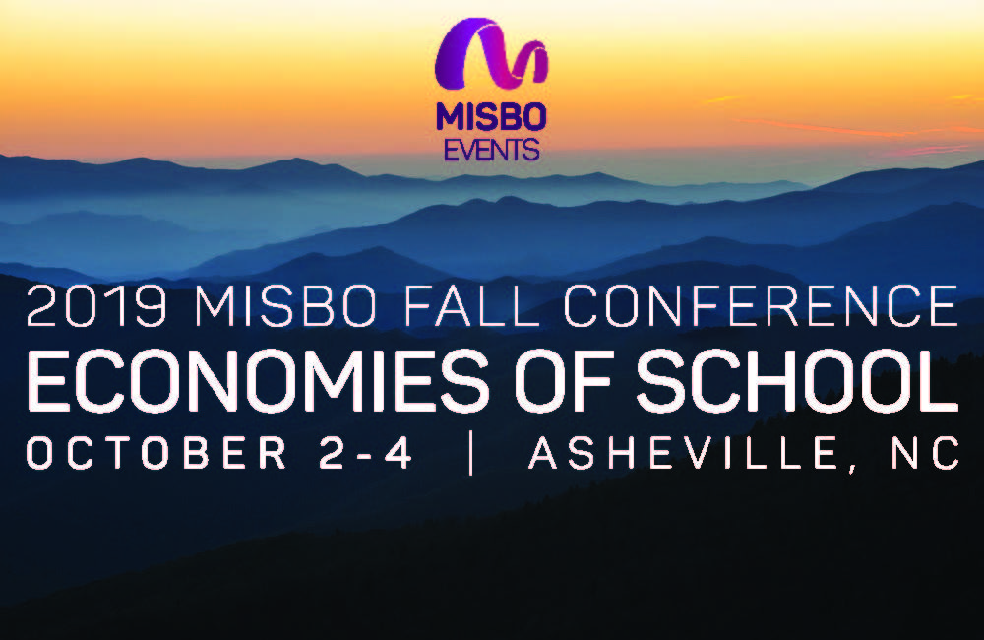

**MISBO Fall Conference Attendance Proposal**

Dear XYZ,

I’m writing to ask for approval to attend the [2019 MISBO Fall Conference – Economies of School](https://www.misbo.com/events/fall19) in Asheville, NC on October 2-4.

Today’s independent school leader requires a strong set of skills. You must possess a sharp financial focus to guide the economic success of your school; recognize, evaluate, and adapt to coming trends; and help to create a safe and healthy community that serves your mission.

Every day, economic factors both inside and outside our industry affect our schools, our communities, and our future. From affordability and value to competition and cost, to managing the daily operations while sustaining the highest quality of education possible; each component of independent school management can bring on new challenges to face daily.

The 2019 MISBO Fall Conference will host presenters in areas of independent school management including finance, compensation, liability and risk management, building successful programs, and why people matter most. These sessions will help us greet the complex changes coming to education through stories of success and failure, and see what we can learn from both.

In particular, I think attending this conference would directly benefit these projects which I am currently working on:

* [add project]
* [add project]
* [add project]

**Here’s an approximate breakdown of conference costs:**

Airfare: $ xxx

Transportation $ xxx

Hotel: $ xxx

Meals: $ xxx

Registration Fee: $ xxx

**Total: $ XXX**

Similar events of this nature are not only more expensive, but they also don’t cover nearly the same scope and breadth of topics. For us to get the best return on investment from this conference, please keep in mind that ***the earlier I can register, the cheaper it will be.***

I’ll give you a summary of what I learned including major takeaways and new ideas. As a participant, I will also have access to all the speaker presentation slides following the event that can also be shared with our administration and faculty.

Thank you for considering this request. I look forward to your reply.

Regards,