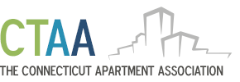

**NAA ADVOCATE POLICY**

**PURPOSE:**

This policy has been created to document the CTAA's position on funding the cost of attending Advocate.

**POLICY:**

The CTAA will pay for up to 5 Board Members or Committee Chairs to attend Major NAA events. Travel and expenses associated with the event will be paid for or reimbursed in accordance with the CTAA Travel Policy.

**PROCEDURE:**

The 5 spots will be made available to Board members first. Any remaining available spots will be made available to Committee Chair members. The spots are on a first come first serve basis. Board Members will be notified via email, the first to respond will be allowed to attend. If all 5 spots are not spoken for at the Board level the same email method will be utilized at the Committee Chair level.

**EXCLUSIONS:**

This policy only applies when the individual at the Board or Chair level is otherwise not able to be paid in full or in part directly by their employer. This policy only applies to persons in good standing with the association.