**Lt. Col. Vincent Beasley**

**Memphis Police Department**

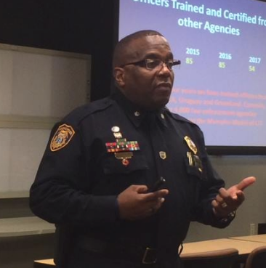

Lt. Col. Beasley has nearly 30 years of law enforcement experience, having served as Commander of MPD’s Training Academy, the Law Enforcement Officer Support Division and the Crisis Intervention Team. He is certified as an instructor in numerous topics, including Crisis Intervention Training, Hostage Negotiations, Trauma in Law Enforcement, and Domestic Violence. He holds a B.S. in Business Management from UT Martin, and a M.S. from the University of Phoenix in Organizational Management. Lt. Col. Beasley also has a master’s degree in Specialized Training with an emphasis on Emergency/Disaster Preparedness and Response Management through the military, and a PhD in Business Management from Trinity University in Dallas TX. He served 26 years in the Armed Forces and retired as a Lieutenant Colonel from the United States Army Reserve.